**BIT302**

**Software Engineering**



**ASSIGNMENT 3**

**Design & Test Document**

**“Web-based Information System for MicroHousing System in Kuala Lumpur”**

**Team Leader:**

**Luh Wulandari Maharani**

**E1700873 / 170030401**

**luhwulandari@gmail.com**

**Member:**

**Rivaldo Bagus Soepardhy**

**E1700882 / 170030400**

**aldobagus@hotmail.co.id**

Table of Content

Introduction 1

Use Case Diagram 2

Architectural Design 3

Class Diagram Design 4

Entity Relationship Diagram (ERD) 5

Sitemap 6

Wireframe (General UI Design) 7

System Sequence Diagram + Contracts 16

Database Design 30

Iteration 1 31

Use Case 31

Test Objectives 32

Test Plan 32

Unit Testing 33

Integration Testing 51

System Testing 52

Test Analysis Report 67

Updated Gantt Chart, Trello Board, GitHub 68

Introduction

Every software development must have a clear and understandable requirement or specification to ensure developers can keep developing software within the boundary of requirement, while also, developer can adjust to what users need with the software, and developers can optimize the software according to users’ need.

Previously, we already created the general requirement of what kind tools and how our web-based information system will be developed. In this document, we will give you the design specification and other deliverables regarding to the project, such as SSD, ERD, Database Design, Wireframe, etc.

Use Case Diagram

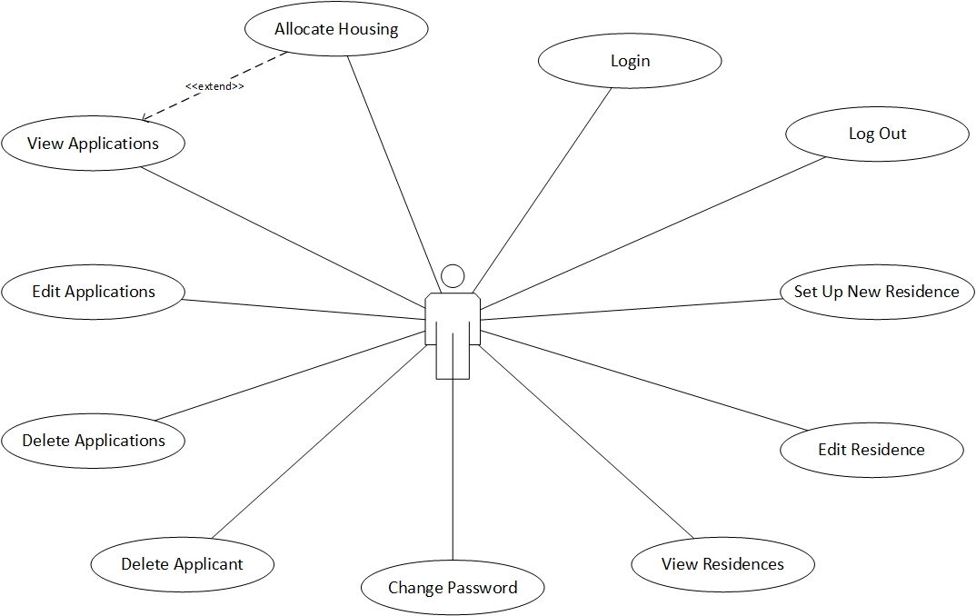

*Use Case Diagram with Actor HousingOfficer*

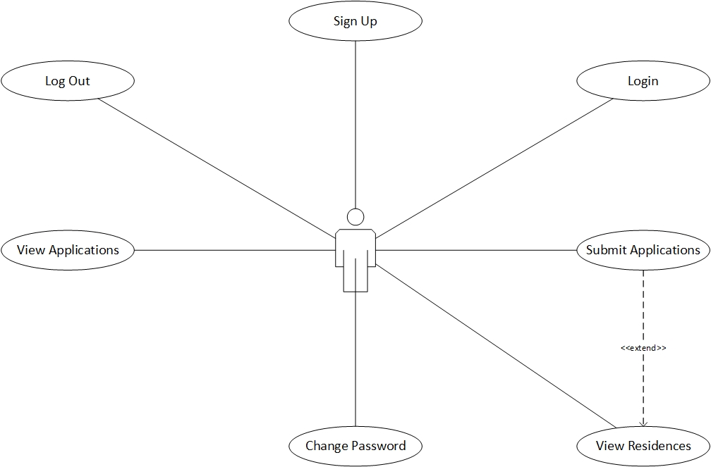

*Use Case Diagram with Actor Applicant*

Architectural Design

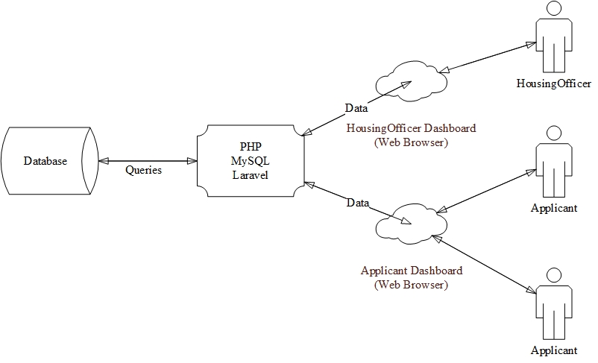

Class Diagram Design

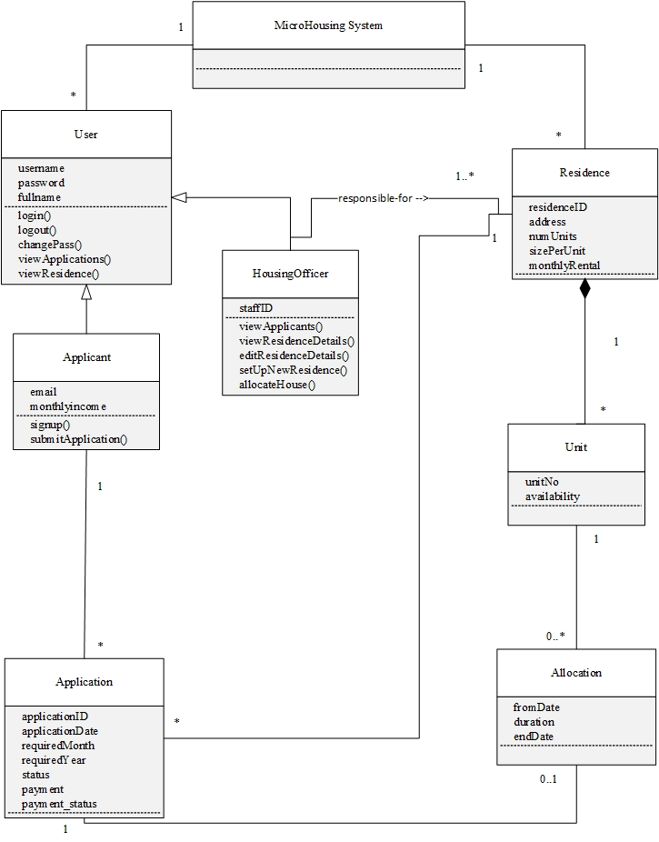

Entity Relationship Diagram (ERD)

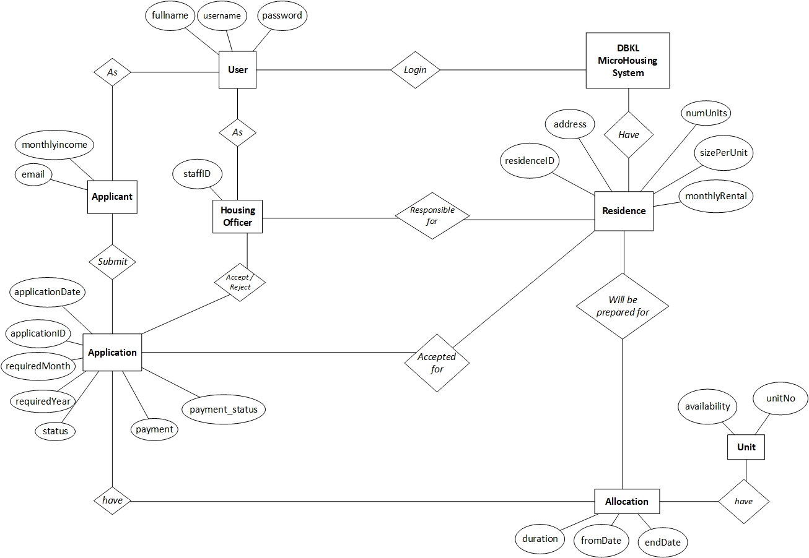

Sitemap

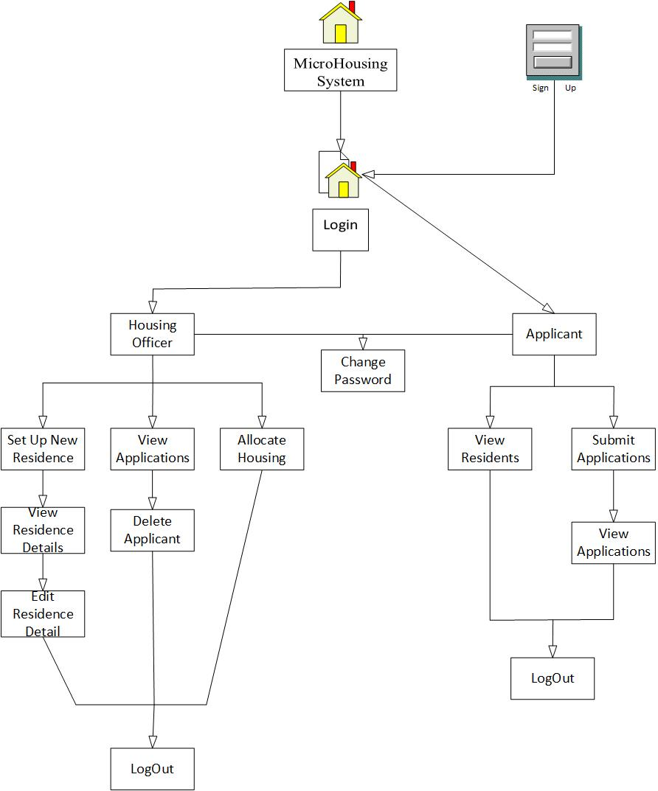

Wireframe

Housing Officer

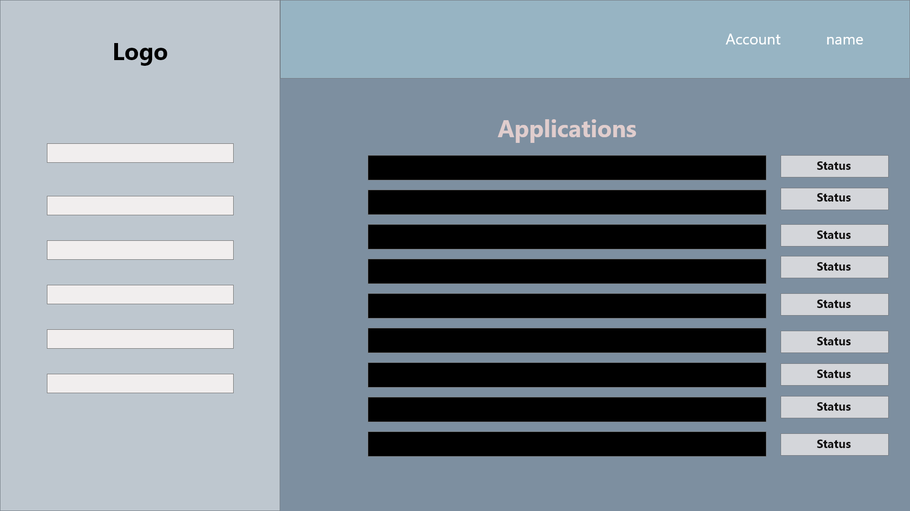

*Allocate Housing*

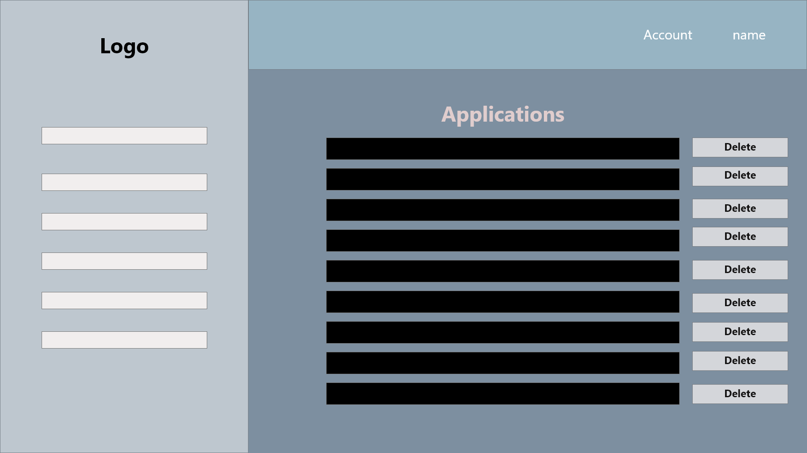

*Delete Application*

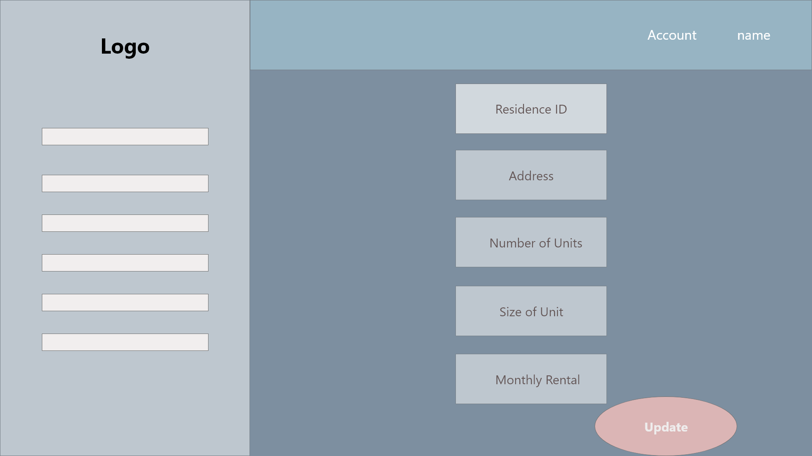

*Edit Residence*

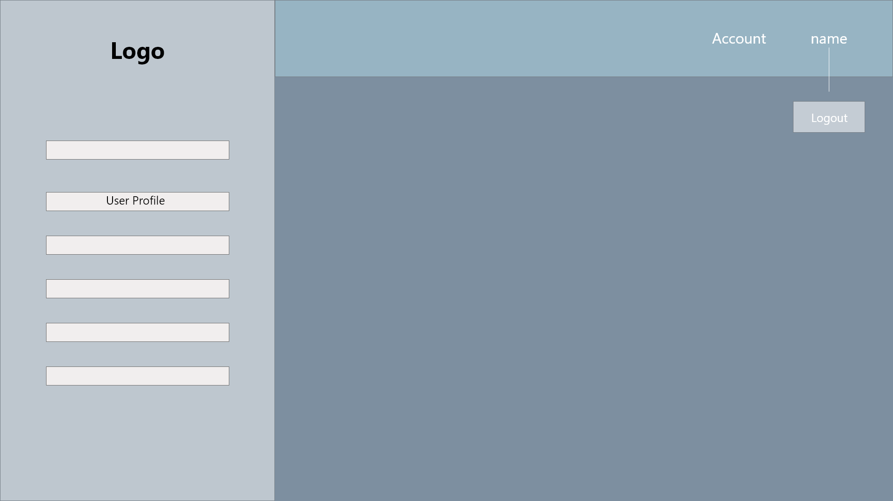

*Logout*

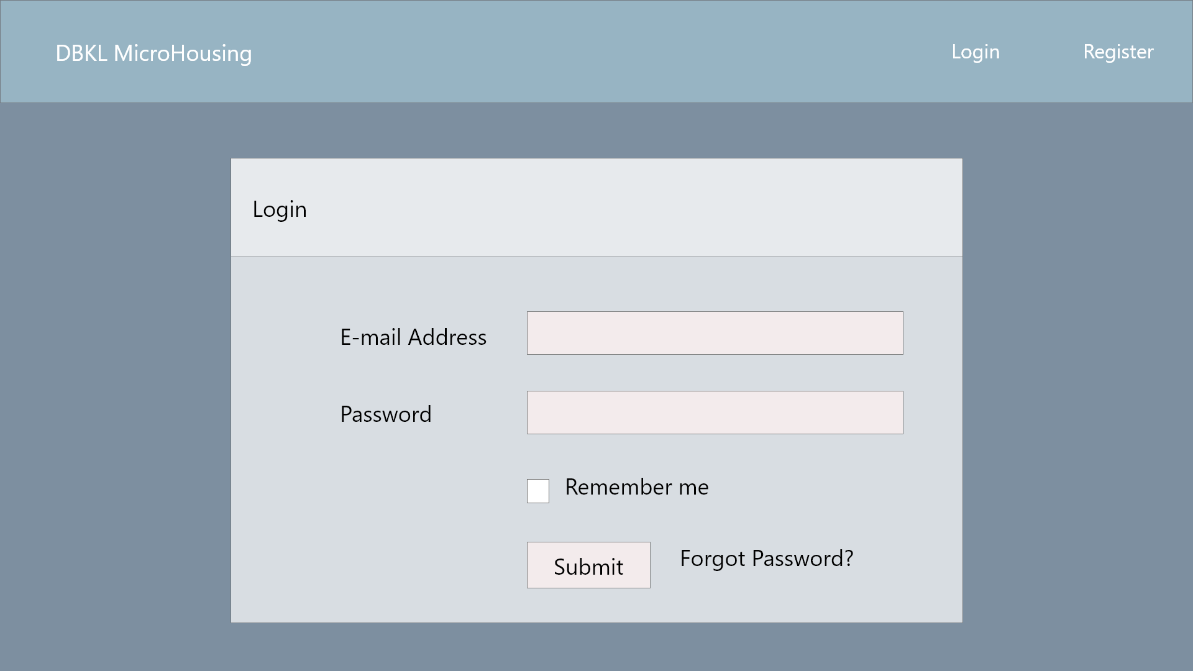

*Login*



*My Profile*

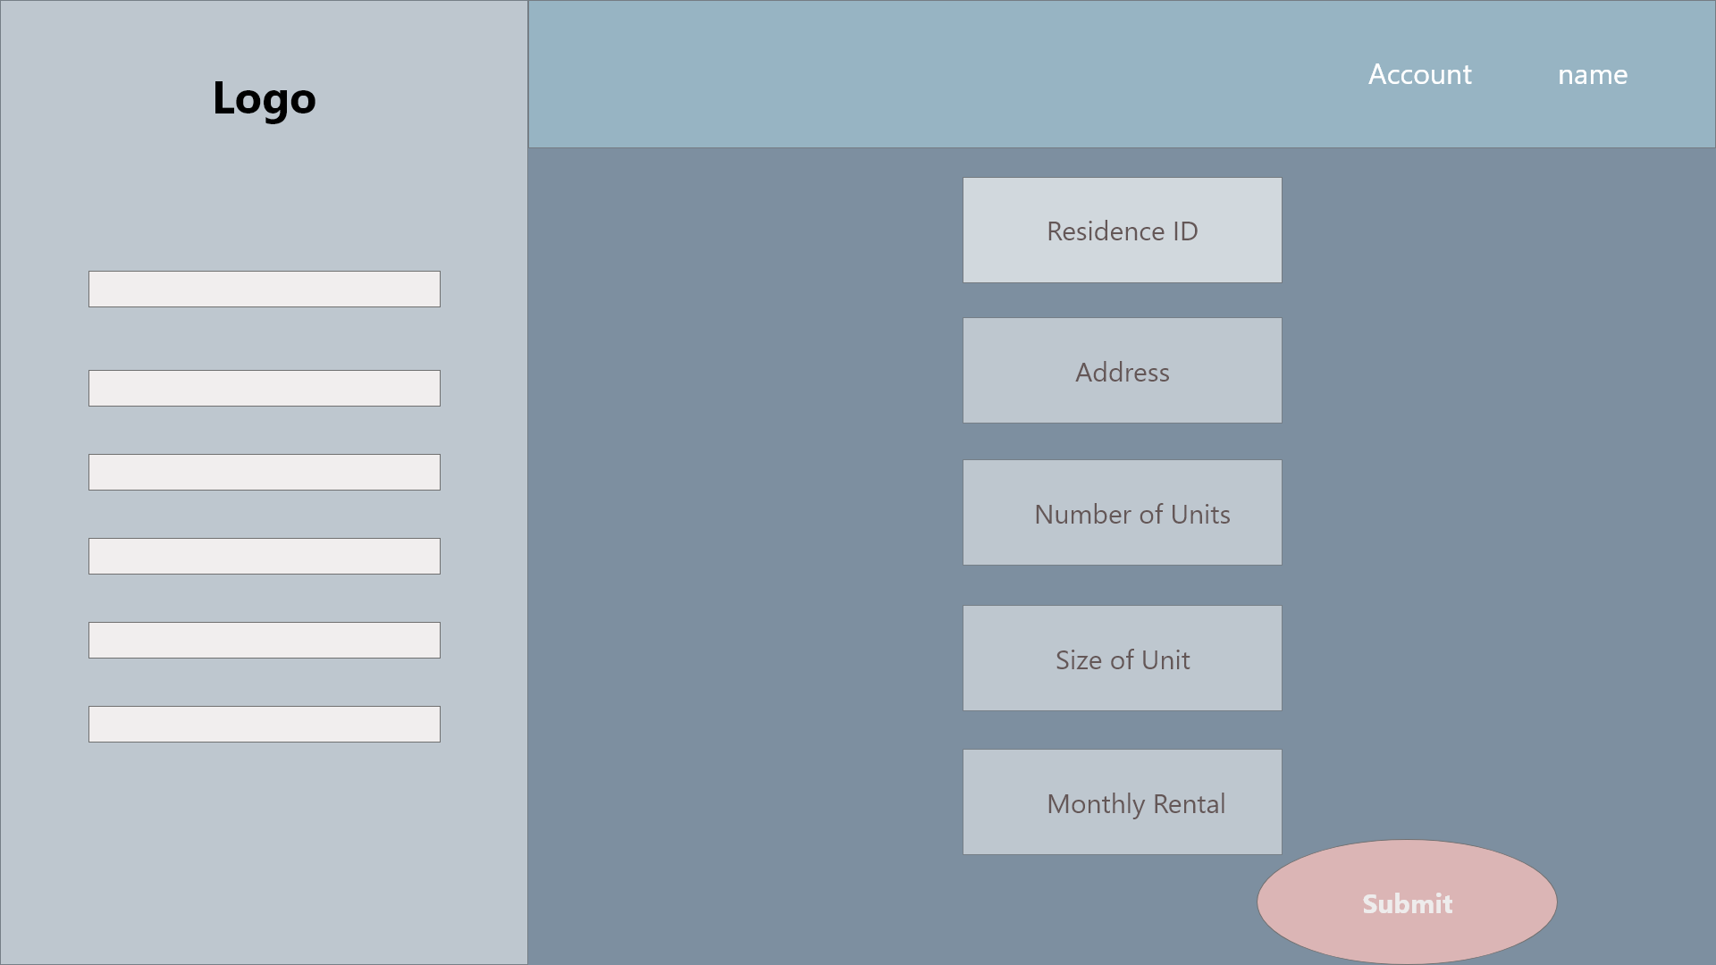

*Set Up New Residence*

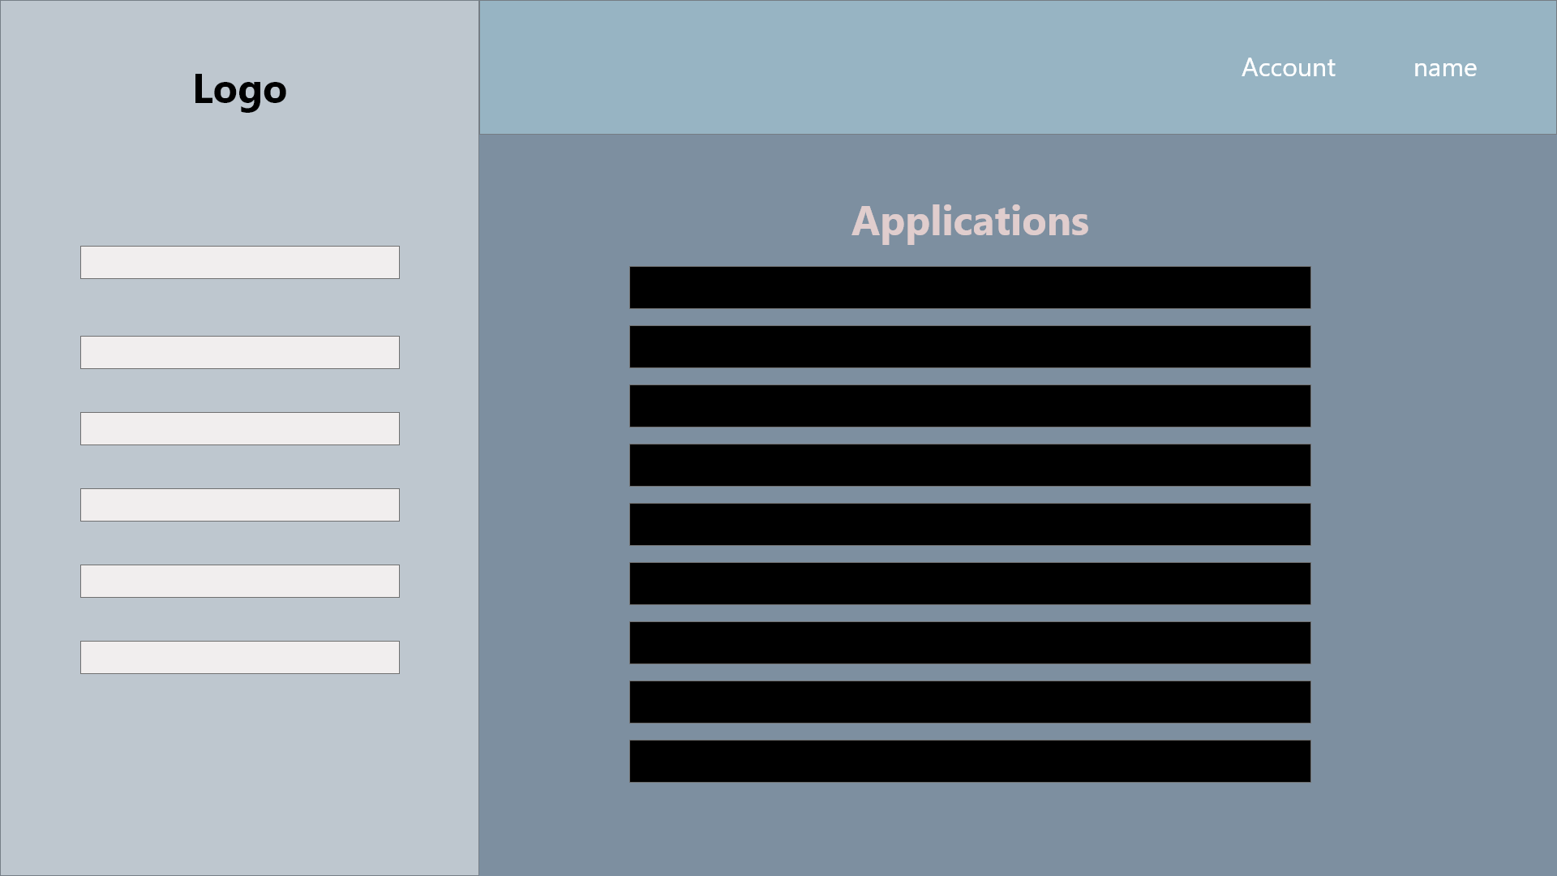

*View Applications*

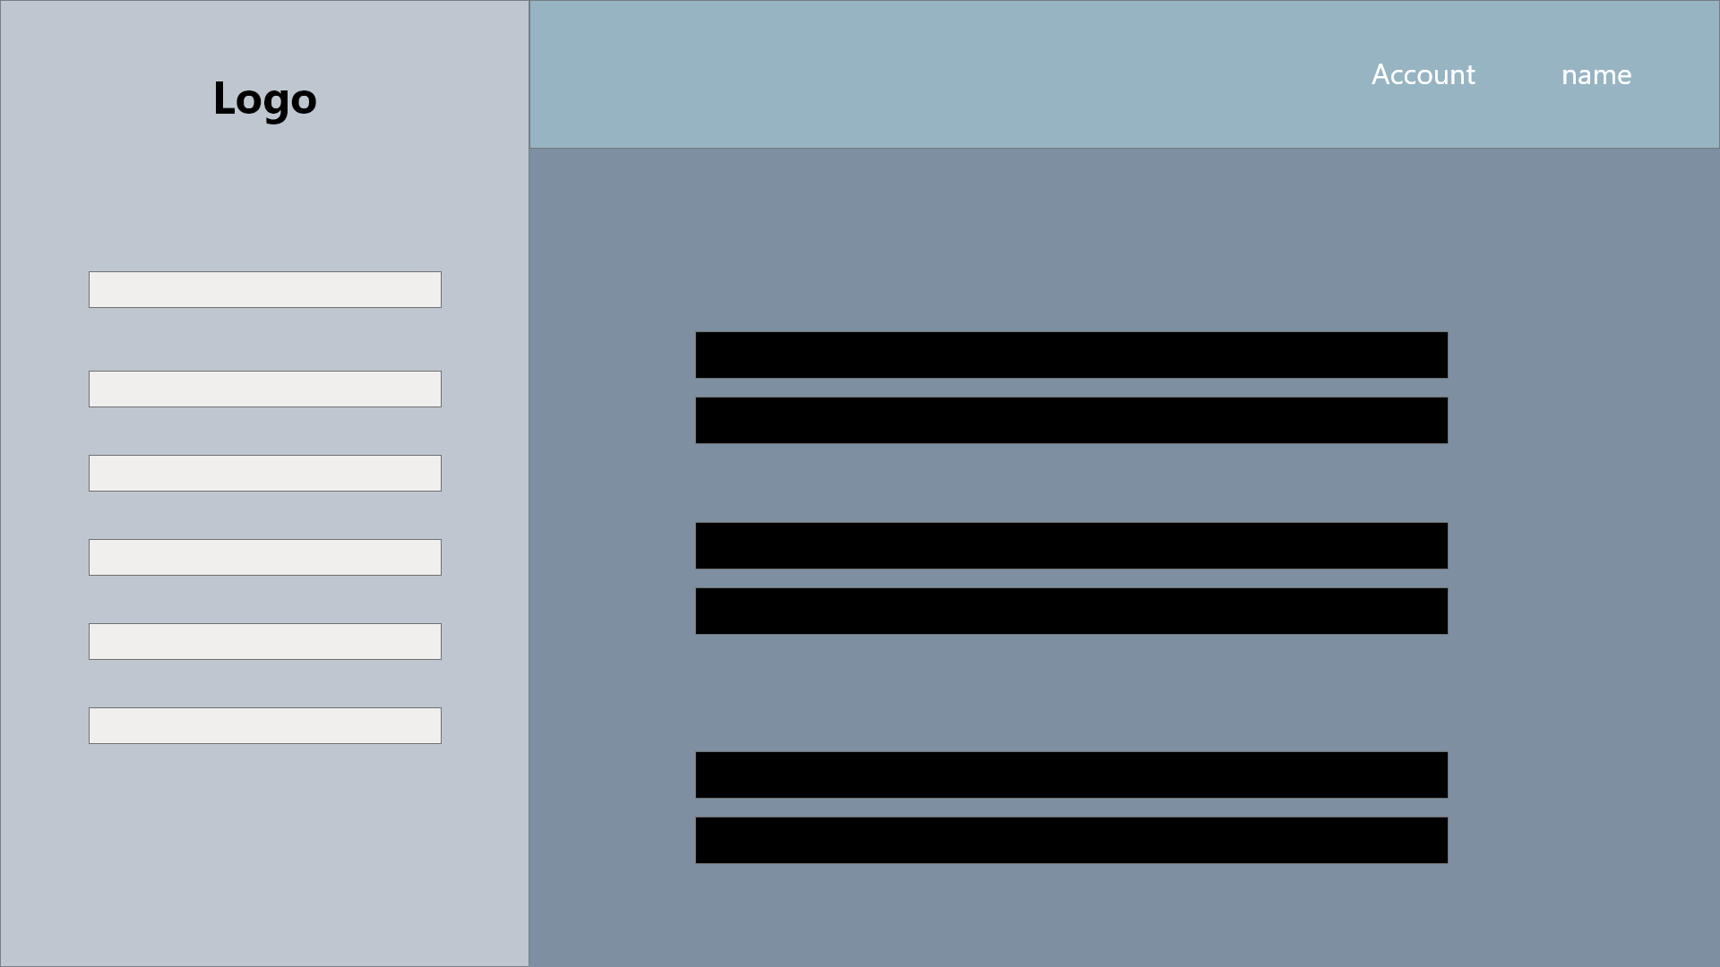

*View Residence*

Applicant

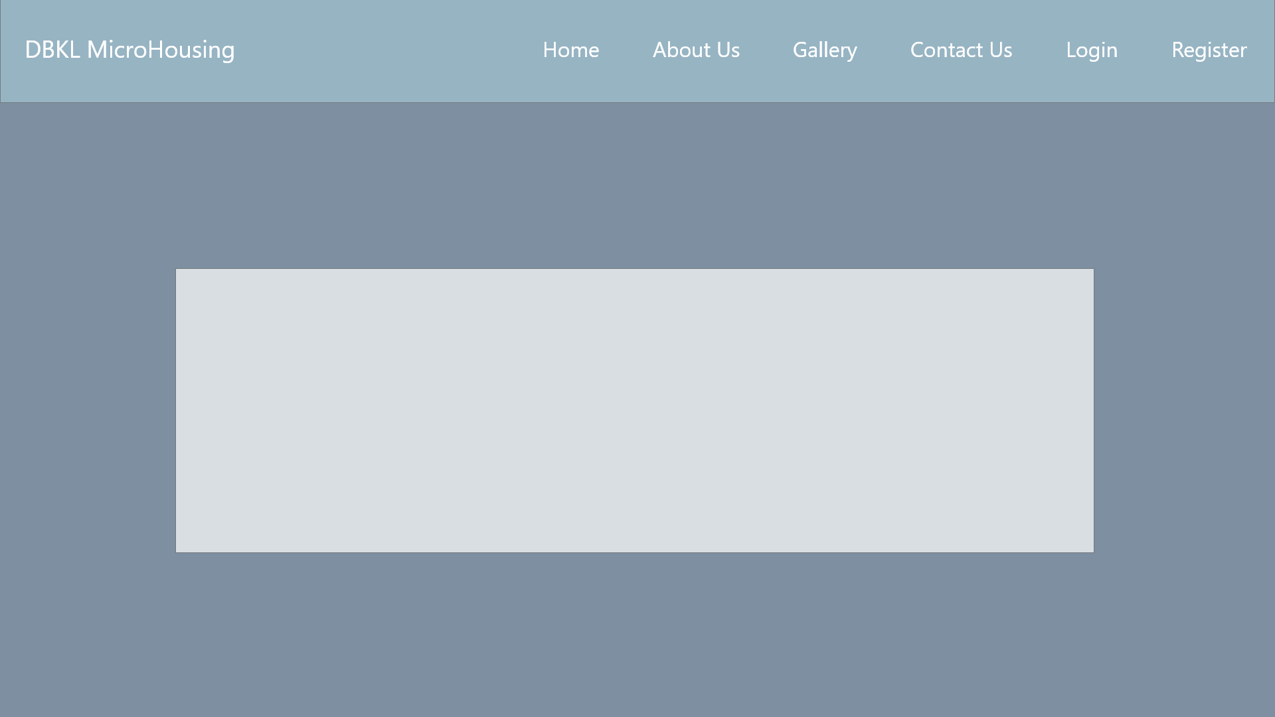

*Homepage*



*Login*

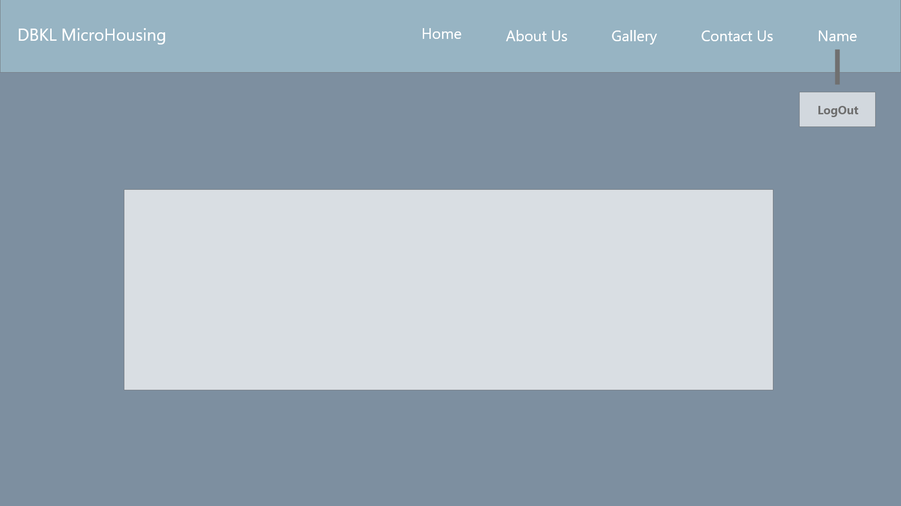

*Logout*

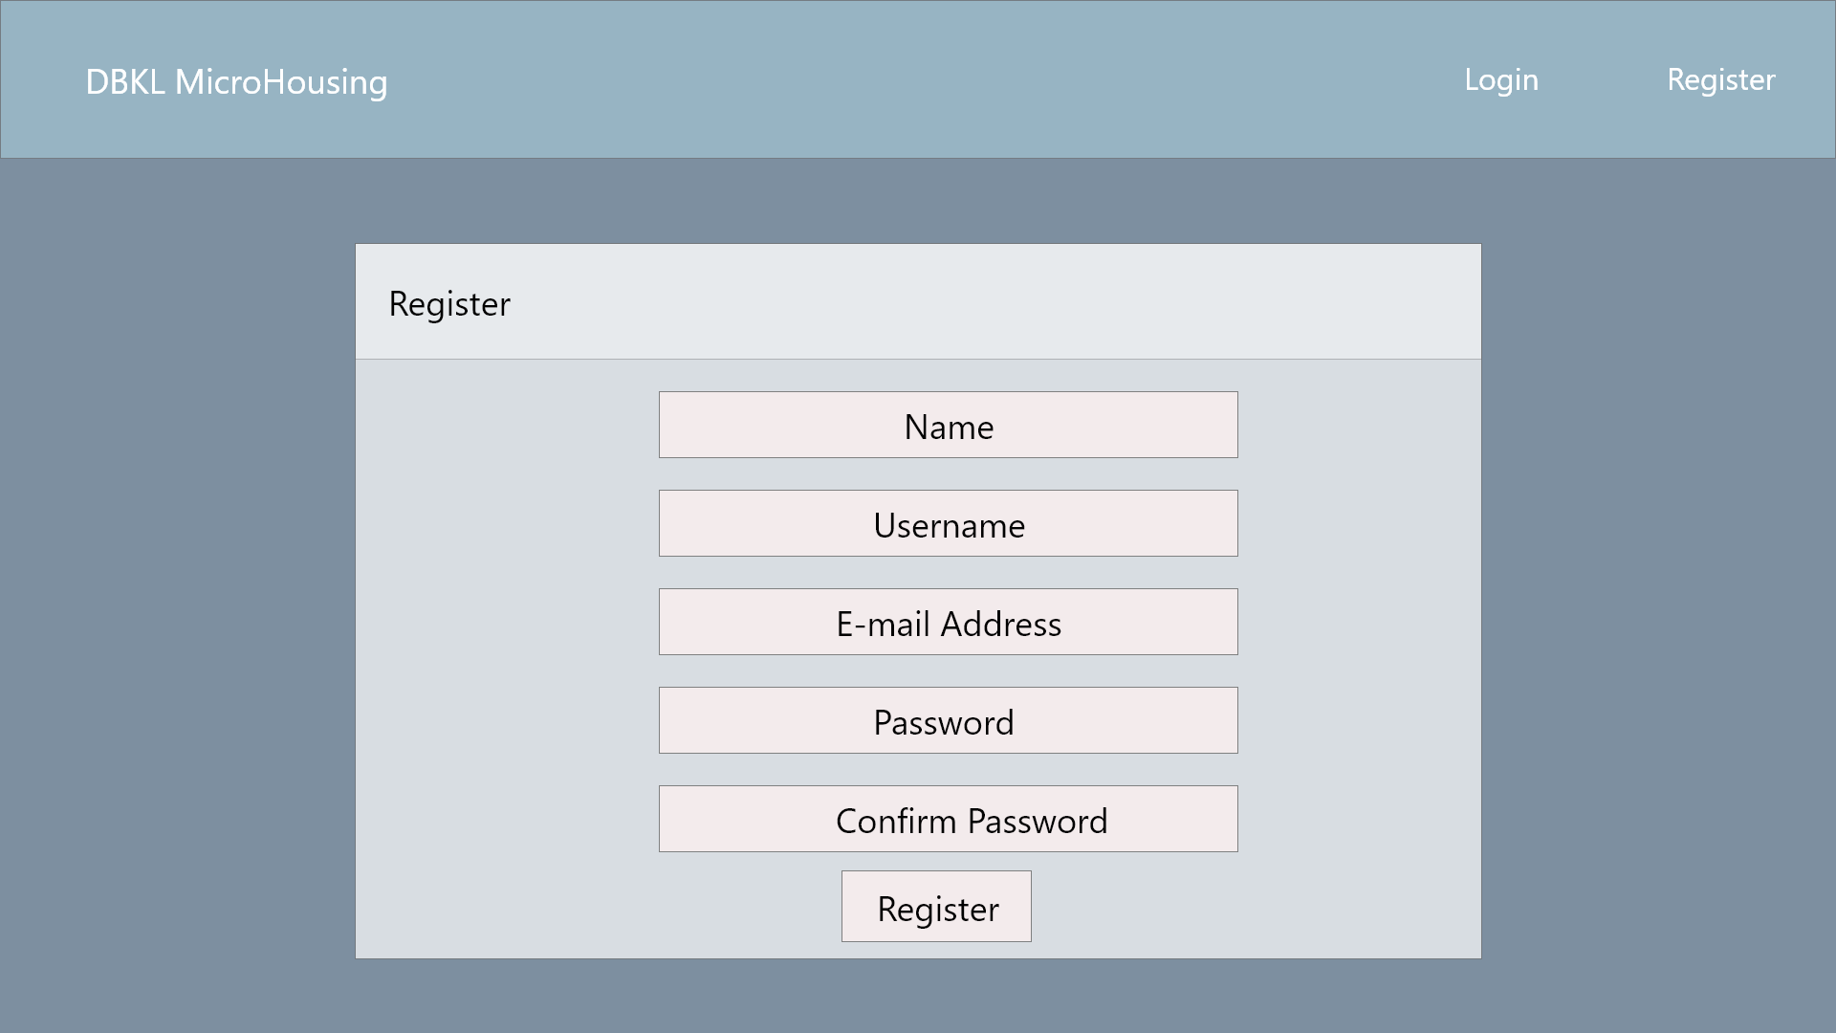

*Register*

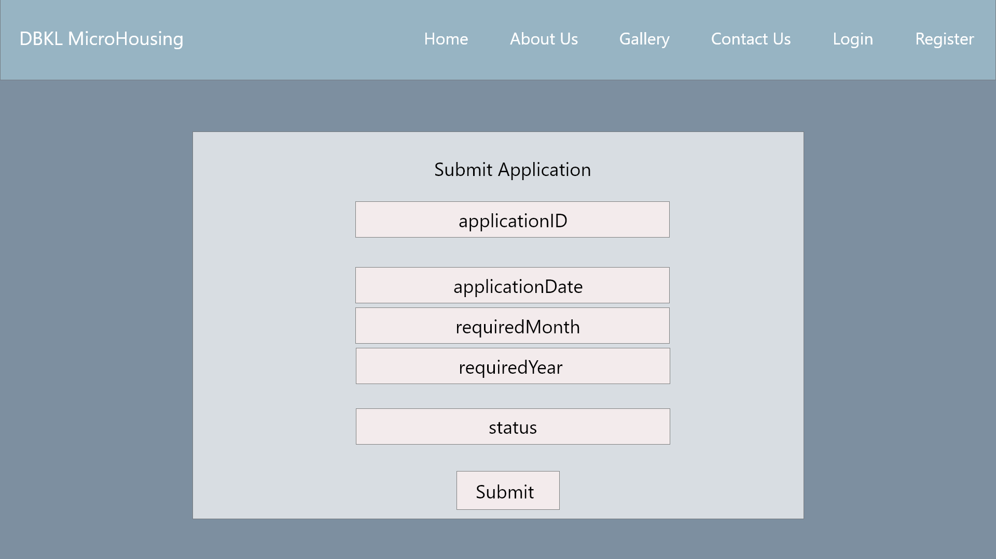

*Submit Applications*

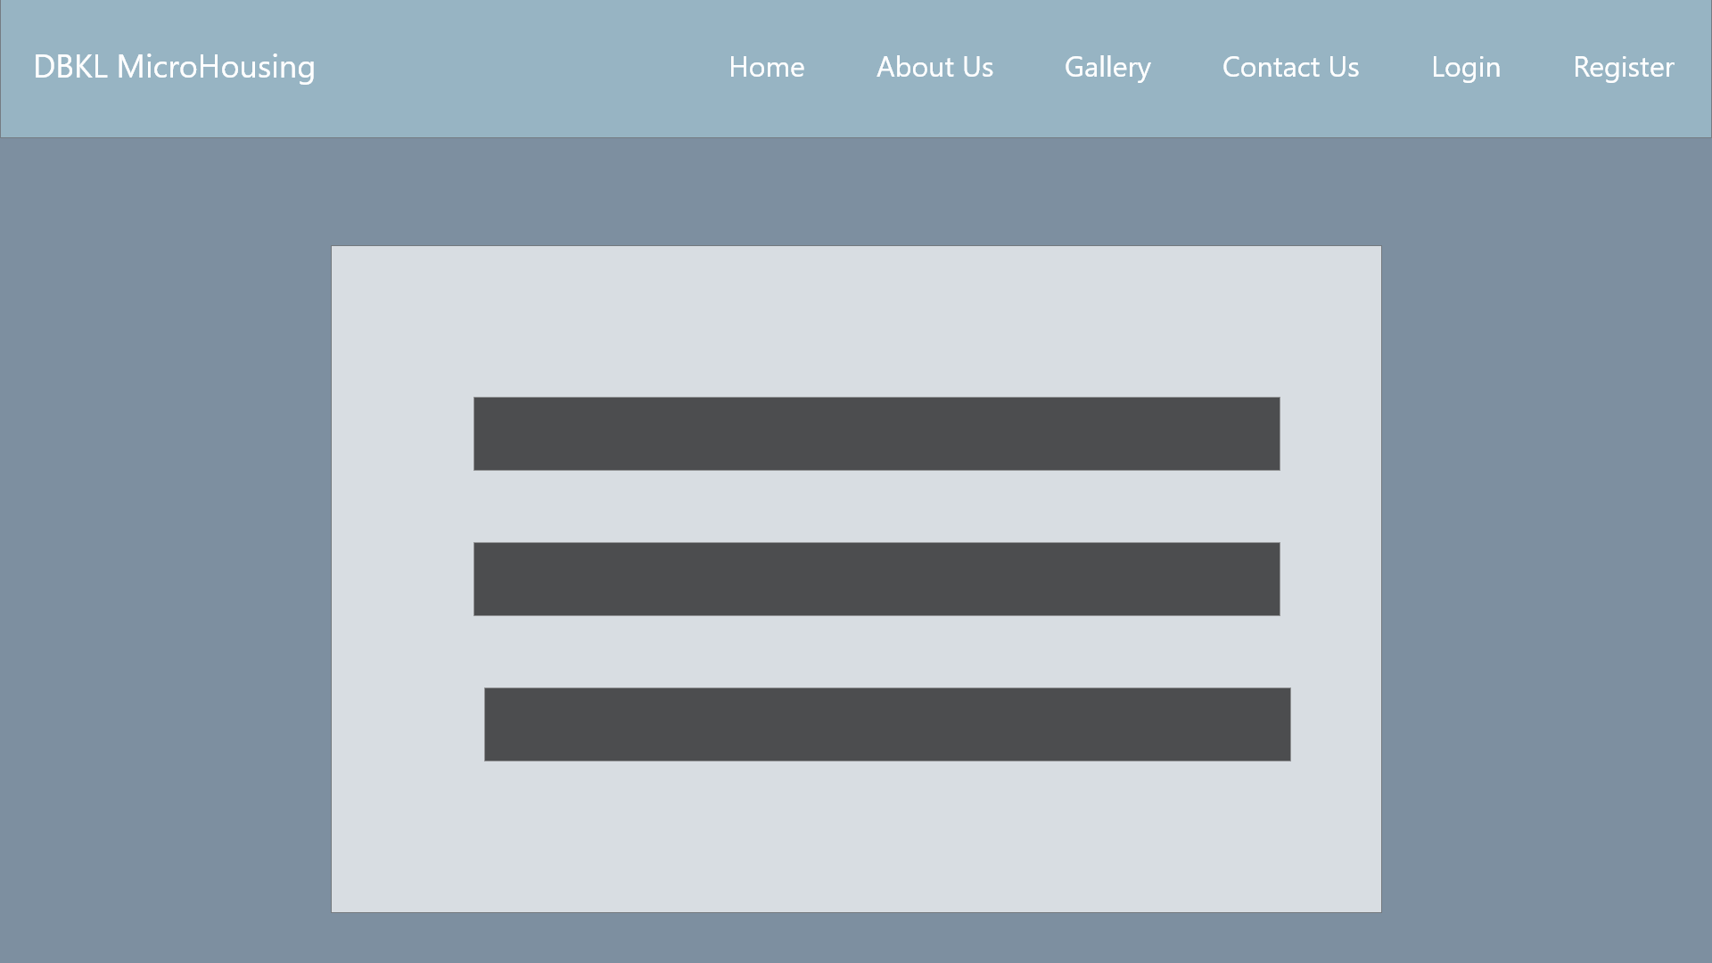

***View Applications***

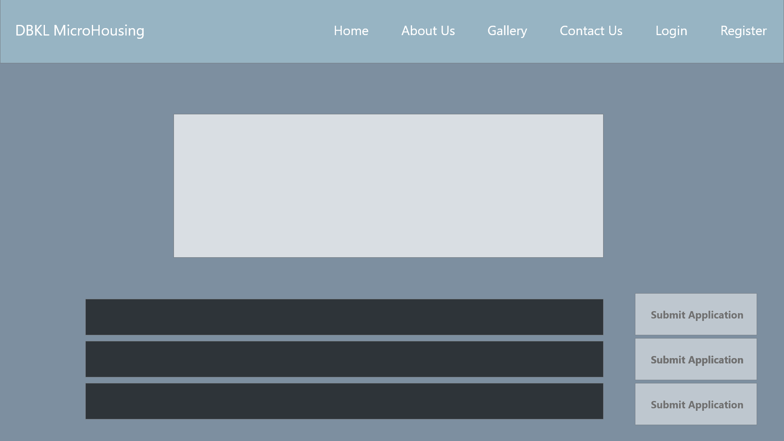

*View Residence*

System Sequence Diagram + Contracts

1. **Login**

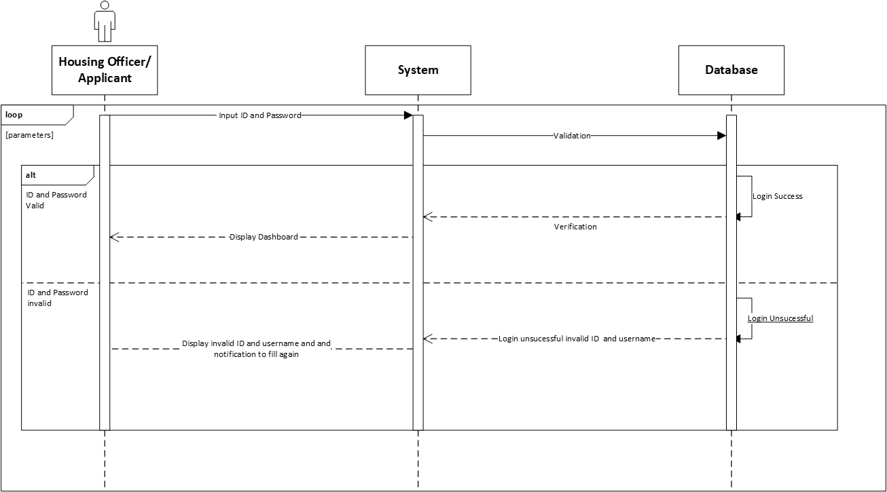

**Prepared by: Luh Wulandari Maharani**

|  |  |
| --- | --- |
| **Cross References** | **Login** |
| Operation | Login with ID and username |
| Responsible | To access the main page |
| Pre-conditions | * Username must be available * Password must be available |
| Post-conditions | * Username is matched * Password must be match based on user’s password input * Display dashboard |

1. **Change Password**

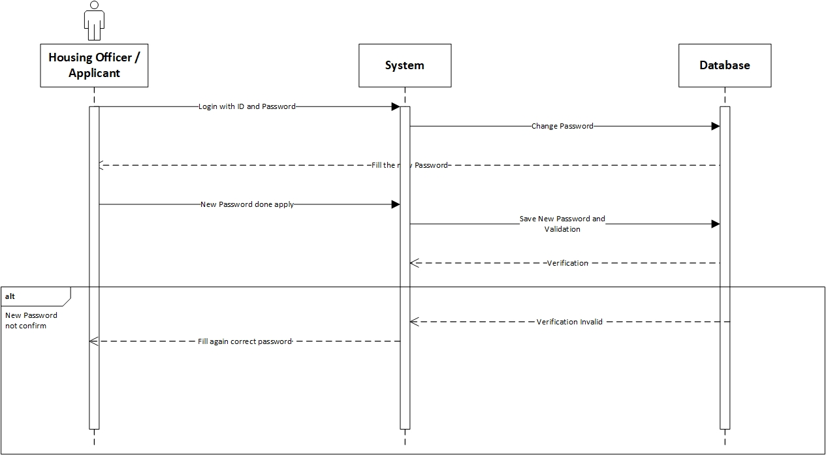

**Prepared by: Luh Wulandari Maharani**

|  |  |
| --- | --- |
| **Cross References** | **Change Password** |
| Operation | Enter current password |
| Responsible | To change the password |
| Pre-conditions | The new password must be available |
| Post-conditions | Successfully changed password |
| **Cross References** | **Change Password** |
| Operation | Enter current password |
| Responsible | To change the password |
| Pre-conditions | The user must be enter the new password again to confirm |
| Post-conditions | Fill again the form with the new password |

1. **Log Out**

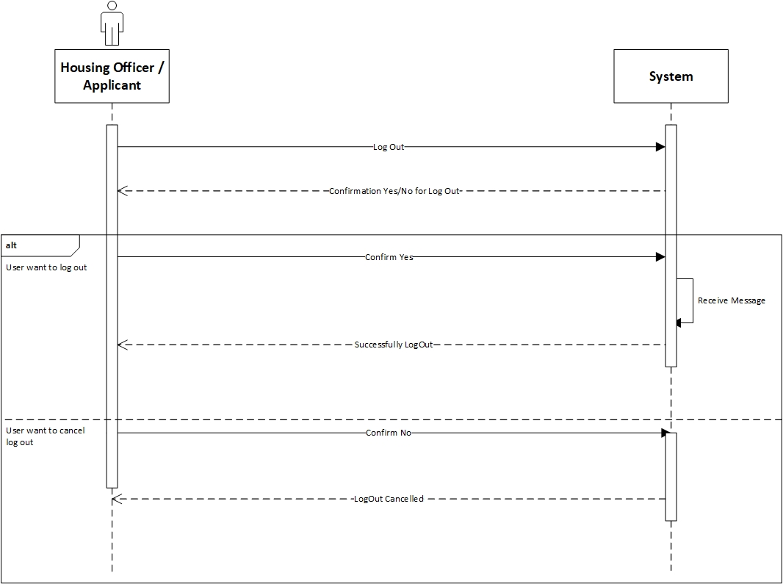

**Prepared by: Luh Wulandari Maharani**

|  |  |
| --- | --- |
| **Cross References** | **Log Out** |
| Operation | User want to log out |
| Responsible | To log out from the system |
| Pre-conditions | The user accepts that they want to log out |
| Post-conditions | Successfully log out |
| **Cross References** | **Log Out** |
| Operation | Cancel to log out |
| Responsible | To cancel log out from the system |
| Pre-conditions | The user cancel log out by click the “No” option |
| Post-conditions | Log out cancelled |

1. **View Applications**

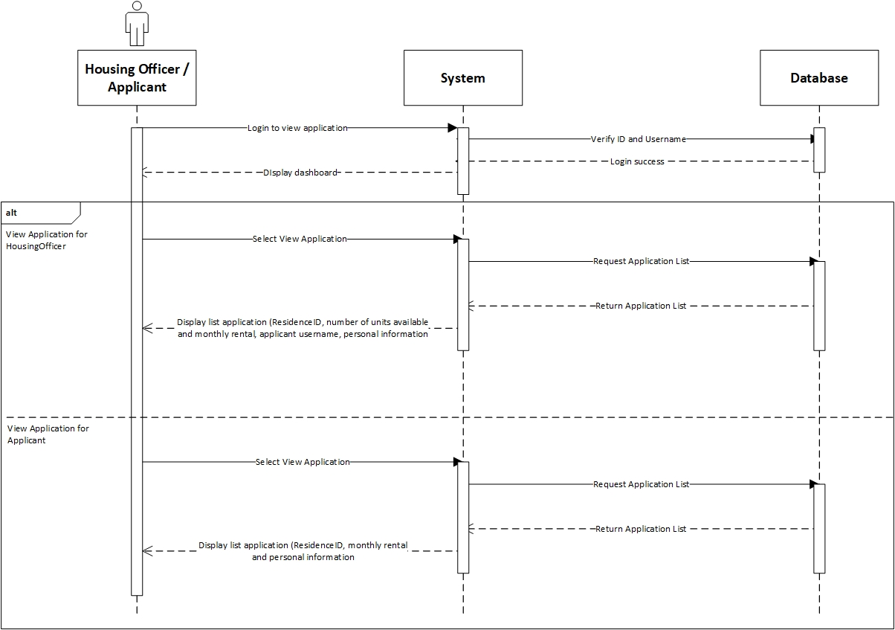

**Prepared by: Luh Wulandari Maharani**

|  |  |
| --- | --- |
| **Cross References** | **View Applications** |
| Operation | Login with username and password |
| Responsible | To get access to view the applications |
| Pre-conditions | * Username must be available * Password must be available |
| Post-conditions | * Username is matched * Password must be match based on user’s password input * Display dashboard |
| **Cross References** | **View Applications** |
| Operation | View Application in Housing Officer |
| Responsible | To view a list for the Residence that Housing Officer is responsible |
| Pre-conditions | The application object must be available |
| Post-conditions | The list of application with status for the Residence that the Housing Officer is responsible, showing the residence ID, number of units available, monthly rental, application username and personal information |

|  |  |
| --- | --- |
| **Cross References** | **View Applications** |
| Operation | View Application in Applicant |
| Responsible | To view a list of application that have been made for applicant |
| Pre-conditions | The application object must be available |
| Post-conditions | The list of application that have been made by the applicant, showing the residence ID, monthly rental and personal information |

1. **View Residences**

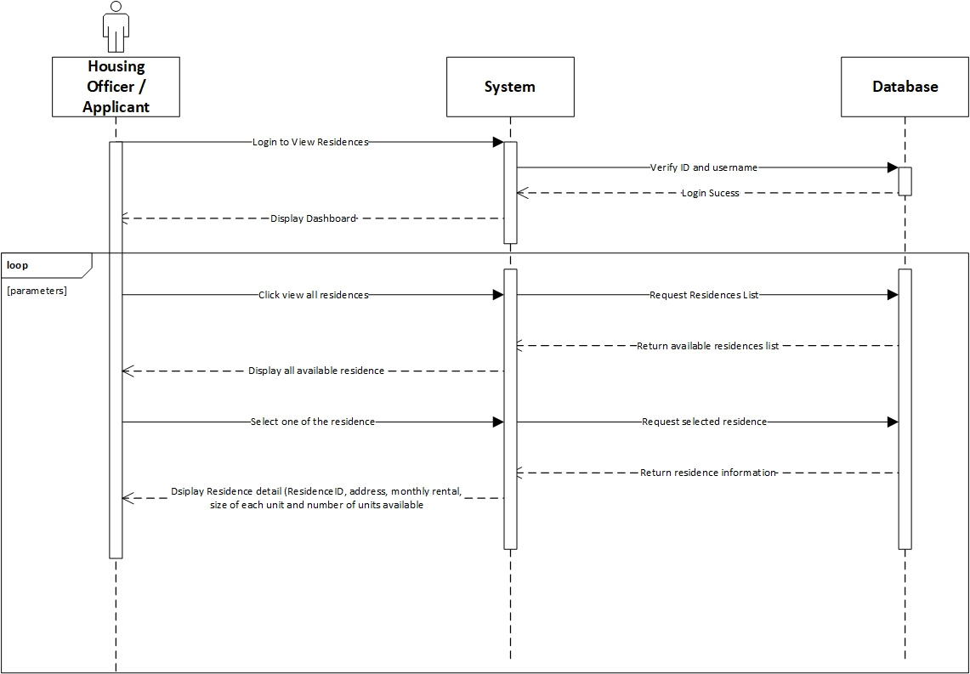

**Prepared by: Luh Wulandari Maharani**

|  |  |
| --- | --- |
| **Cross References** | **View Residences** |
| Operation | Login with ID and username |
| Responsible | To access the main page |
| Pre-conditions | * Username must be available * Password must be available |
| Post-conditions | * Username is matched * Password must be match based on user’s password input * Display dashboard |

|  |  |
| --- | --- |
| **Cross References** | **View Residences** |
| Operation | Click view all residences |
| Responsible | To get all list of the residences |
| Pre-conditions | The residence object must be available |
| Post-conditions | Success to display all residences of all residences |
| **Cross References** | **View Residences** |
| Operation | Select the residence to view |
| Responsible | To get information about selected residences |
| Pre-conditions | The residence ID must be available |
| Post-conditions | Success to display detail information about the selected residences |

1. **Set Up New Residences**

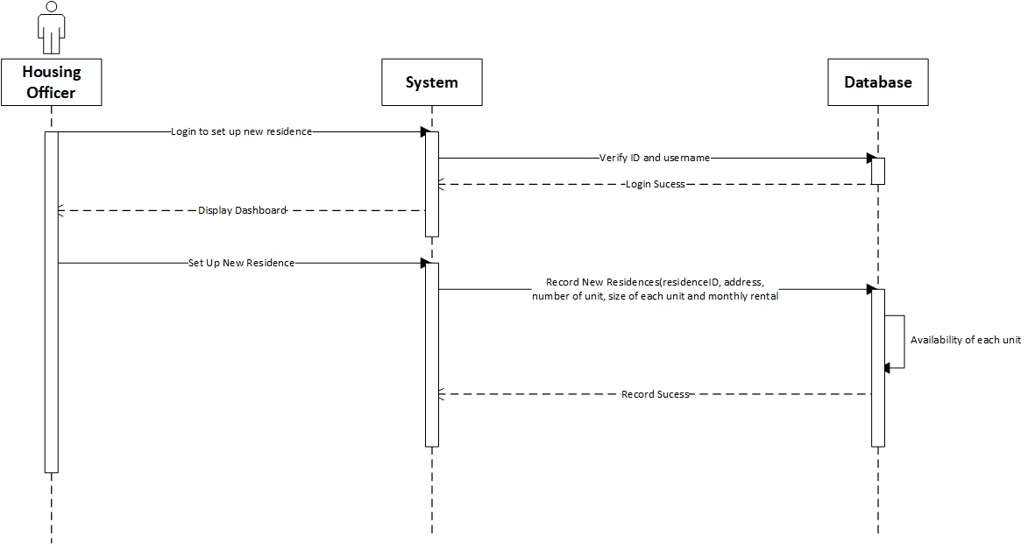

**Prepared by: Luh Wulandari Maharani**

|  |  |
| --- | --- |
| **Cross References** | **Set Up New Residences** |
| Operation | Login with ID and username |
| Responsible | To access the main page |
| Pre-conditions | * Username must be available * Password must be available |
| Post-conditions | * Username is matched * Password must be match based on user’s password input * Display dashboard |

|  |  |
| --- | --- |
| **Cross References** | **Set Up New Residences** |
| Operation | Set up new residences |
| Responsible | To set up the new residences by input the residenceID, address, number of units available, size of each unit and monthly rental |
| Pre-conditions | Object residenceID, address, number of units available, size of each unit and monthly rental must be available |
| Post-conditions | New residences was successfully added to the system |

1. **Allocate Housing**

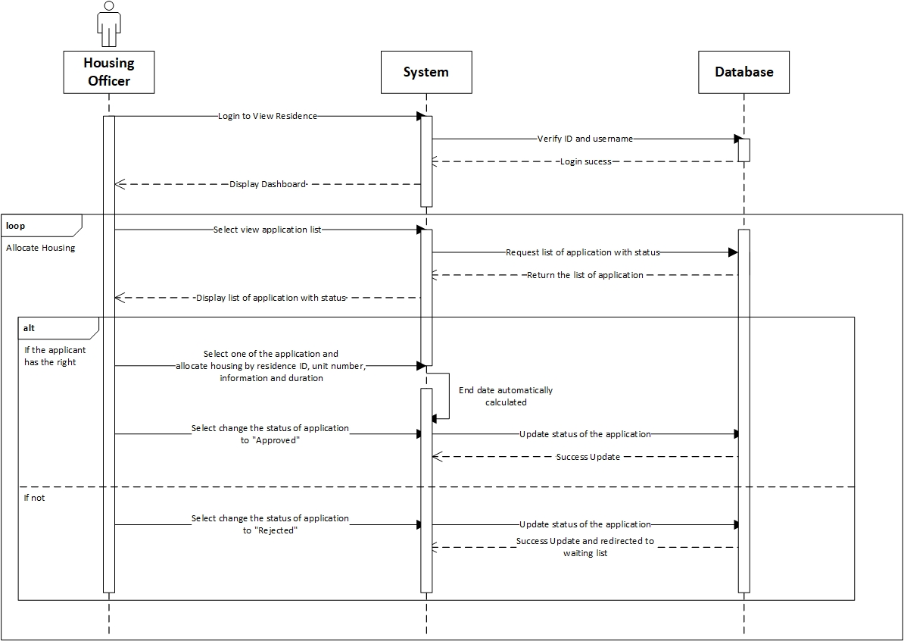

**Prepared by: Luh Wulandari Maharani**

|  |  |
| --- | --- |
| **Cross References** | **Allocate Housing** |
| Operation | Login with ID and username |
| Responsible | To access the main page |
| Pre-conditions | * Username must be available * Password must be available |
| Post-conditions | * Username is matched * Password must be match based on user’s password input * Display dashboard |

|  |  |
| --- | --- |
| **Cross References** | **Allocate Housing** |
| Operation | Select view application list |
| Responsible | To get the list of all application |
| Pre-conditions | The application object must be available |
| Post-conditions | Success displayed list of all application with status |
| **Cross References** | **Allocate Housing** |
| Operation | Select one of the application and allocate the housing |
| Responsible | To allocate the housing for an application |
| Pre-conditions | Object residenceID, unit number, from date and duration must be available |
| Post-conditions | Success create allocation object based on data input |
| **Cross References** | **Allocate Housing** |
| Operation | Select to changed status of to be “Approved” |
| Responsible | To change the status to “Approved” |
| Pre-conditions | Application object must be available |
| Post-conditions | Success changed the application status |
| **Cross References** | **Allocate Housing** |
| Operation | Select to changed status of to be “Rejected” |
| Responsible | To change the status to “Rejected” |
| Pre-conditions | Application object must be available |
| Post-conditions | Success changed the application status and redirected to waiting list |

1. **Sign Up Applicant**

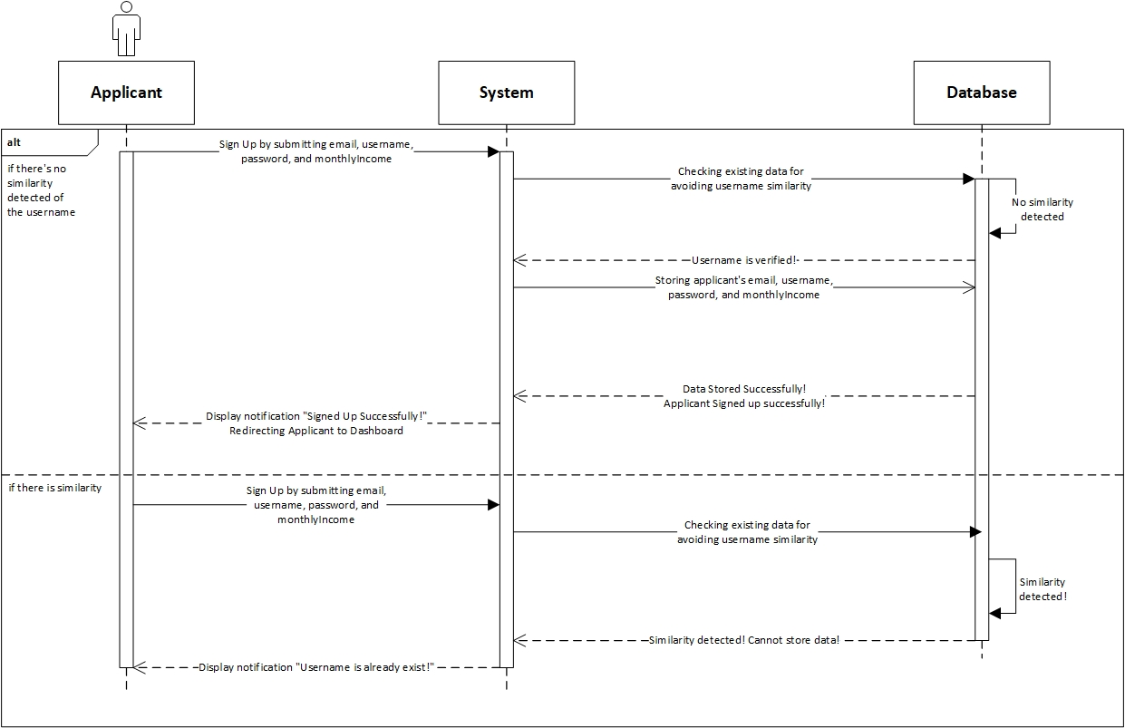

**Prepared by: Rivaldo Bagus Soepardhy**

|  |  |
| --- | --- |
| **Cross References** | **Sign up Applicant** |
| Operation | Sign up with email, username, password, and monthlyIncome |
| Responsible | To be registered in system and able to access the main page |
| Pre-conditions | * Email must be available * Username must be available * Password must be available * MonthlyIncome must be available |
| Post-conditions | * Username is verified (no similarity detected) * Registered in System * Display dashboard |
| **Cross References** | **Sign up Applicant** |
| Operation | Sign up with email, username, password, and monthlyIncome |
| Responsible | To be registered in system and able to access the main page |
| Pre-conditions | * Email must be available * Username must be available * Password must be available * MonthlyIncome must be available |
| Post-conditions | * Username is not verified (already existed in system) * Applicant must re-enter new username. |

1. **Edit Residence**

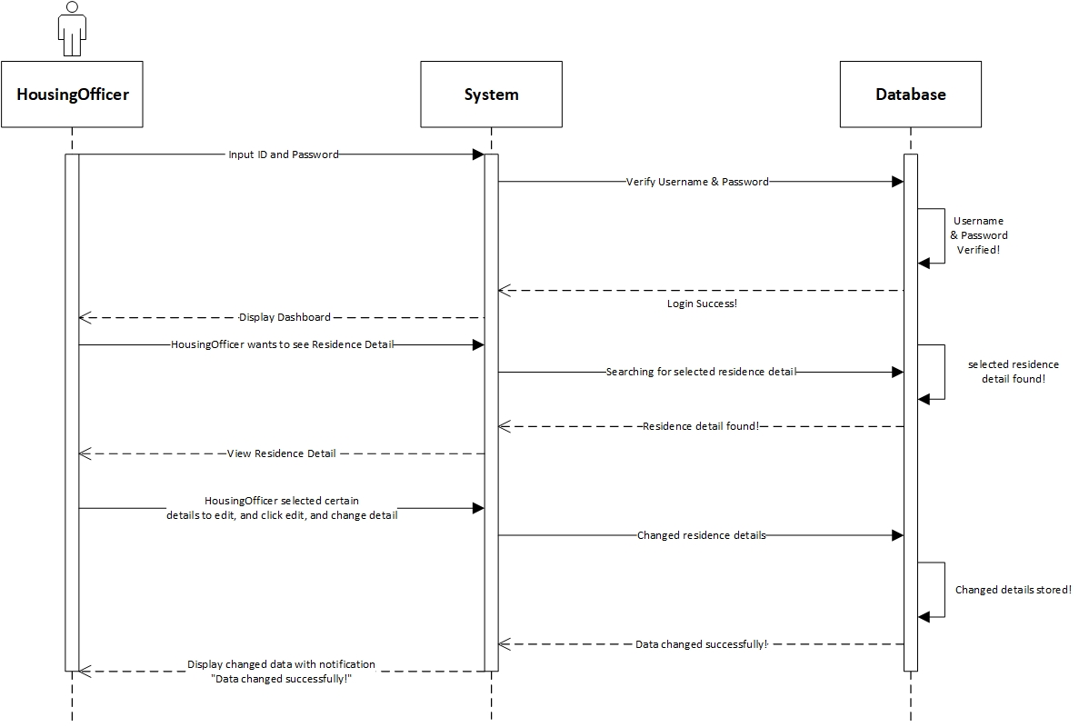

**Prepared by: Rivaldo Bagus Soepardhy**

|  |  |
| --- | --- |
| **Cross References** | **Edit Residence Detail** |
| Operation | Login with username and password |
| Responsible | To get access to view the applications |
| Pre-conditions | * Username must be available * Password must be available |
| Post-conditions | * Username is matched * Password must be match based on user’s password input * Display dashboard |
| **Cross References** | **Edit Residence Detail** |
| Operation | Edit residenceID, address, numUnits, sizePerUnit, monthlyRental |
| Responsible | To change certain Residence Detail |
| Pre-conditions | We will need **one of** or **all of** the details below:   * Email must be available * Username must be available * Password must be available * MonthlyIncome must be available |
| Post-conditions | Residence Detail changed successfully |

1. **Submit Application**

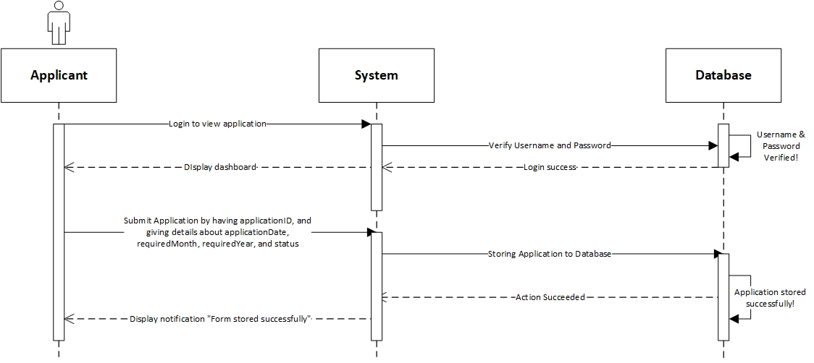

**Prepared by: Rivaldo Bagus Soepardhy**

|  |  |
| --- | --- |
| **Cross References** | **Submit Application** |
| Operation | Login with username and password |
| Responsible | To get access to view the applications |
| Pre-conditions | * Username must be available * Password must be available |
| Post-conditions | * Username is matched * Password must be match based on user’s password input * Display dashboard |
| **Cross References** | **Submit Application** |
| Operation | View Residence & Select Residence |
| Responsible | To submit applicant’s application to the database. |
| Pre-conditions | * Applicant is already logged in to the system * Applicant has already determine the desired residence |
| Post-conditions | User will view the list of the residence, and then select the desired residence. |
| **Cross References** | **Submit Application** |
| Operation | Submit applicationID, applicationDate, requiredMonth, requiredYear, and status |
| Responsible | To submit applicant’s application to the database |
| Pre-conditions | Applicant has already selected the residence. We will need **all of** the details below:   * applicationID will be given by system automatically * applicationDate must be available * requiredMonth must be available * requiredYear must be available * status will be given by system automatically |
| Post-conditions | Application will be stored successfully, and will be on waiting list for the approval & arrangement by HousingOfficer. |

1. **Delete Applicant**

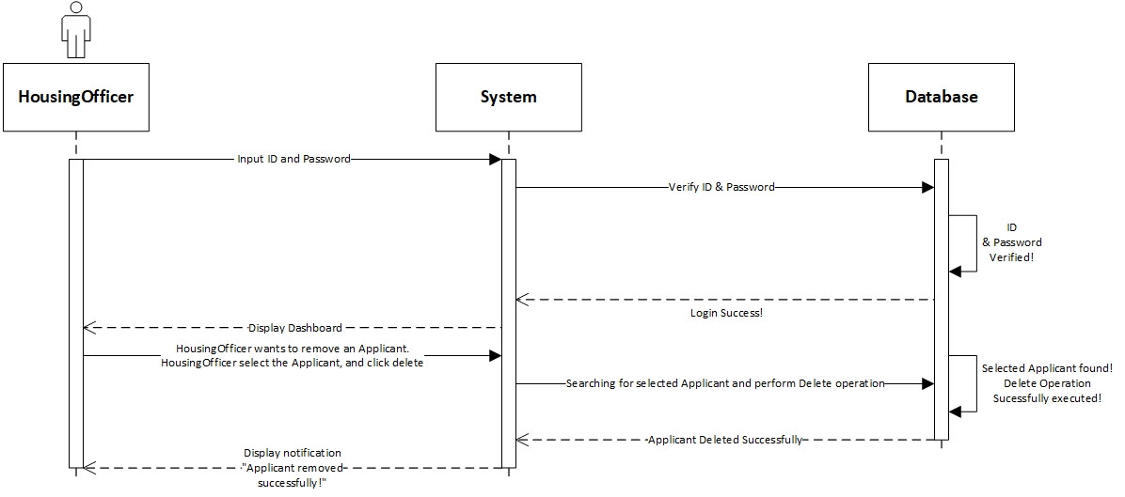

**Prepared by: Rivaldo Bagus Soepardhy**

|  |  |
| --- | --- |
| **Cross References** | **Delete Applicant** |
| Operation | Login with ID and username |
| Responsible | To access dashboard, and delete applicant |
| Pre-conditions | * Username must be available * Password must be available |
| Post-conditions | * Username is matched * Password must be match based on user’s password input * Display dashboard |
| **Cross References** | **Delete Applicant** |
| Operation | Delete Applicant |
| Responsible | To remove an applicant |
| Pre-conditions | The applicant object must be available, and the applicant is no longer in place (checkout) |
| Post-conditions | Applicant object will be removed successfully |

1. **Delete Applications**

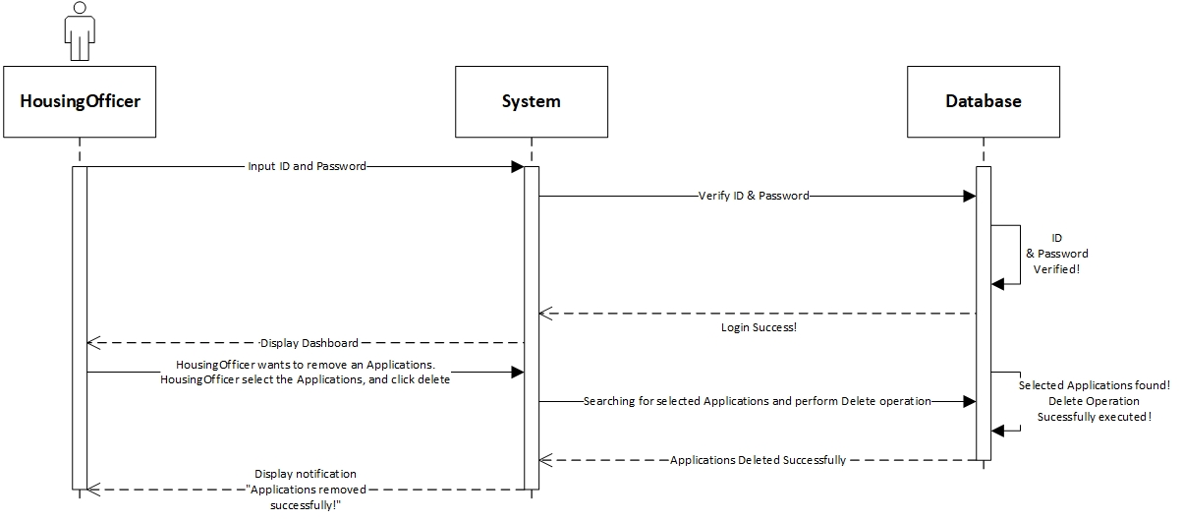

**Prepared by: Luh Wulandari Maharani**

|  |  |
| --- | --- |
| **Cross References** | **Delete Applications** |
| Operation | Login with ID and username |
| Responsible | To access dashboard, and delete applicant |
| Pre-conditions | * Username must be available * Password must be available |
| Post-conditions | * Username is matched * Password must be match based on user’s password input * Display dashboard |
| **Cross References** | **Delete Applications** |
| Operation | Delete Applications |
| Responsible | To remove an applications |
| Pre-conditions | The applications object must be available, and the applications is no longer in place (checkout) |
| Post-conditions | Applications object will be removed successfully |

1. **Edit Applications**

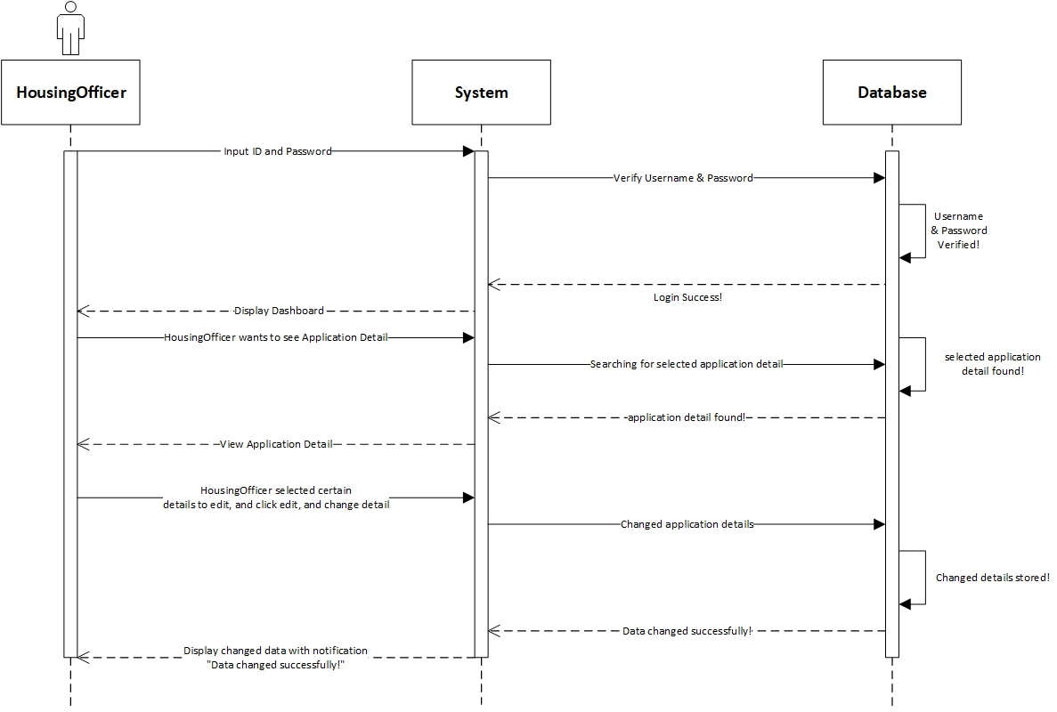

**Prepared by: Luh Wulandari Maharani**

|  |  |
| --- | --- |
| **Cross References** | **Edit Applications** |
| Operation | Login with username and password |
| Responsible | To get access to view the applications |
| Pre-conditions | * Username must be available * Password must be available |
| Post-conditions | * Username is matched * Password must be match based on user’s password input * Display dashboard |
| **Cross References** | **Edit Applications Detail** |
| Operation | Edit status, payment and payment status |
| Responsible | To change certain Applications Detail |
| Pre-conditions | We will need **one of** or **all of** the details below:   * applicantID must be available * residenceID must be available * requiredMonth must be available * requiredYear must be available |
| Post-conditions | Applications changed successfully |

Database Design

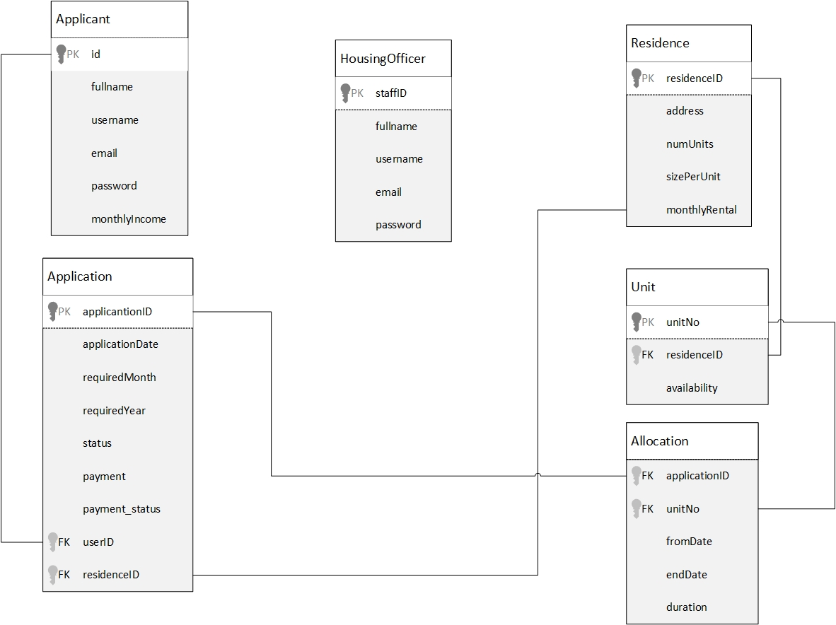

Iteration 1

Use Case

|  |  |  |
| --- | --- | --- |
| Use Case | Developed By | Testing |
| Login | Wulan | Iteration 1 |
| SignUp (For Applicant) | Wulan | Iteration 1 |
| Change Password | Wulan | Iteration 2 |
| Log Out | Wulan | Iteration 1 |
| View Application (HousingOfficer) | Wulan | Iteration 1 |
| Delete Application (HousingOfficer) | Wulan | Iteration 2 |
| Edit Application (HousingOfficer) | Wulan | Iteration 2 |
| Allocate Housing(HousingOfficer) | Wulan | Iteration 2 |
| Set Up New Residence(HousingOfficer) | Wulan | Iteration 1 |
| View Residence(HousingOfficer) | Wulan | Iteration 1 |
| Edit Residence(HousingOfficer) | Wulan | Iteration 1 |
| Delete Applicant(HousingOfficer) | Wulan | Iteration 2 |
| Submit Application(Applicant) | Aldo | Iteration 1 |
| View Applications(Applicant) | Aldo | Iteration 1 |
| View Residences(Applicant) | Aldo | Iteration 1 |

Test Objectives

The main reason of the testing of this system is very obvious and inevitable, to find mistakes or errors inside the system. Although there is no such a “perfect system”, it does not mean that we keep making systems without consideration and thorough testing. With this testing and a high frequency of testing, it will build confidence of the software quality, thus making us sure, the software will be very robust. Testing is not only about finding errors or mistake, but also to analyze the system and countering any possibility of errors that can possibly happen in the future.

For DBKL MicroHousing information system, our first objective is to make sure login validation works and password data is successfully encrypted with encryption provided by the framework we use to work. Then we test the application (web pages) across different web browser to ensure it is working properly. Next, we test the system according to the role:

* As HousingOfficer, he/she should be able to do basic CRUD (Create, Read, Update, Delete) operation in the system on certain object, such as residence, allocation, etc. HousingOfficer will be able to do some deciding action regarding application, whether to apply or reject it.
* As Applicant, he/she should be able view data only related to his role and application, such as Application Status, Payment, Residence, etc.

We also have to test all the links, buttons, pages, are working properly and directing to the right pages.

Test Plan

For the information system, we will be testing functions that will be performed by HousingOfficer and Applicant. We want to make sure that system boundaries are working. For example, Applicant cannot edit or delete data. Login system will also be tested, so that HousingOfficer and Applicant will be redirected to their own dashboard. During the testing process, we will test a function with several times of repeat to verify that the function has worked perfectly.

Unit Testing

1. **Register for Applicant**

This create_users_table function is used to make a users table in the microhousing database and declare each variable which will be used for the register applicant.

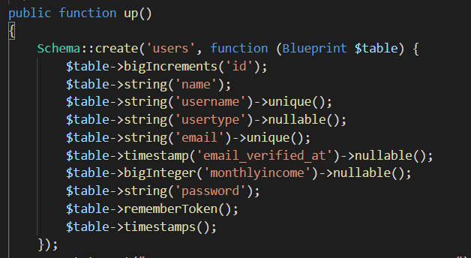

This registerContoller function is use to validate input from user when registering as an Applicant to the DBKL Microhousing. If applicant input invalid information the system will not accept the information and display an error from invalid input from the applicant.

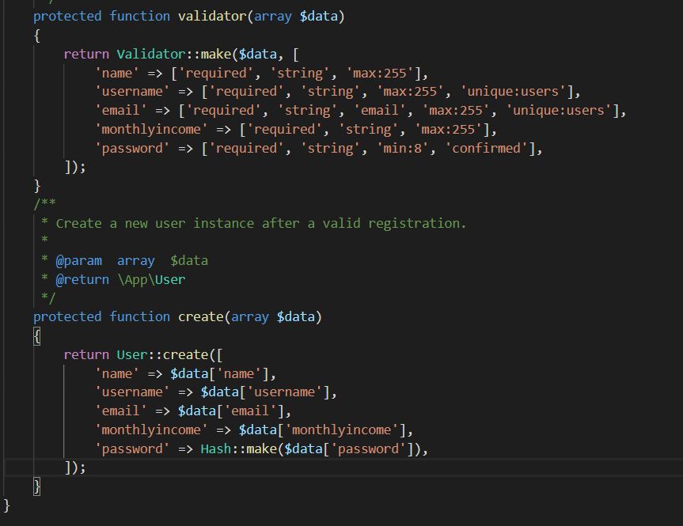

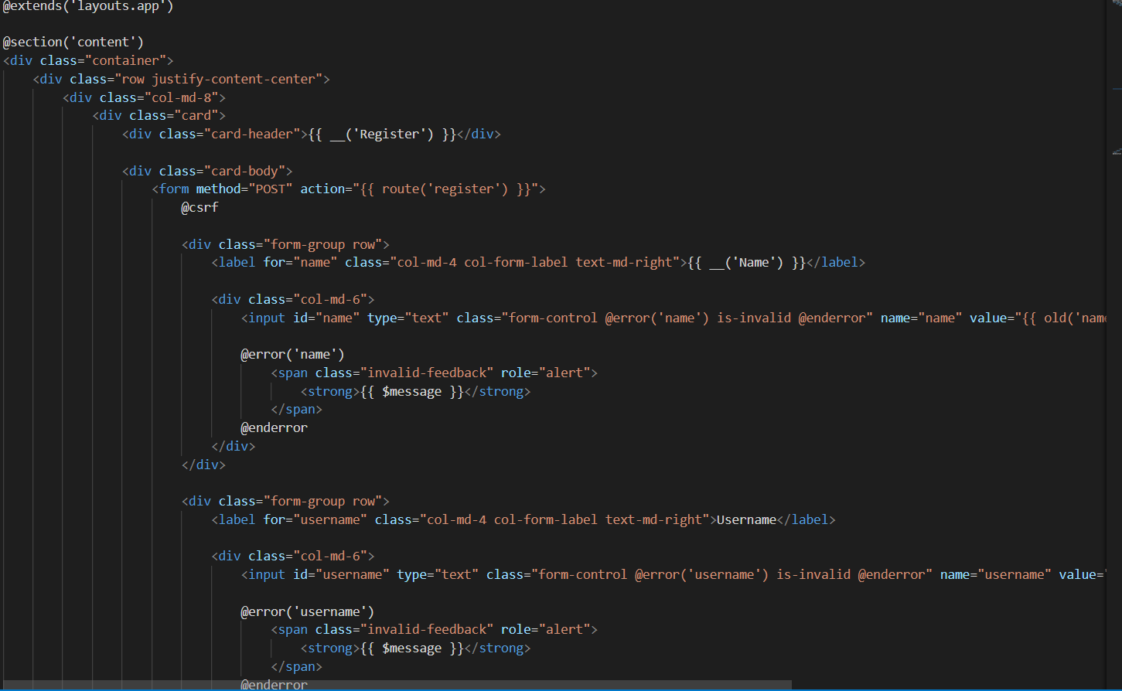

This $fillable is register the attribute (column name) that we can fill in when inserting or updating to the database.

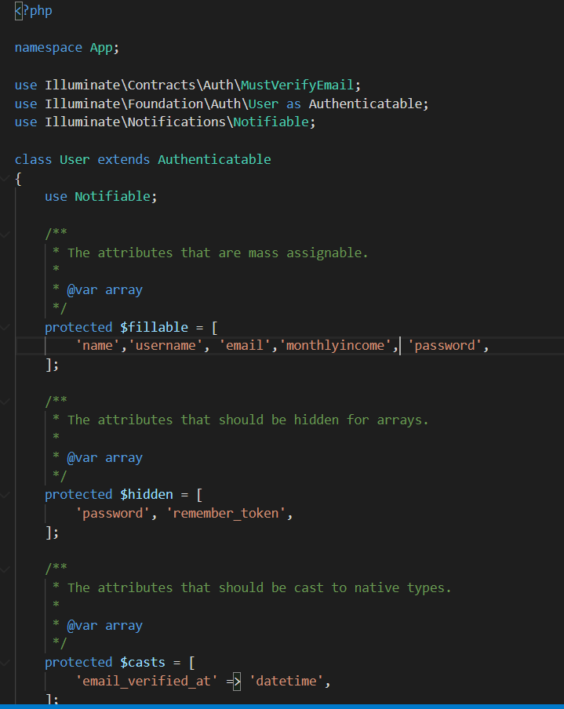

1. **Applicant input blank information**

The required rule function was complete successfully.

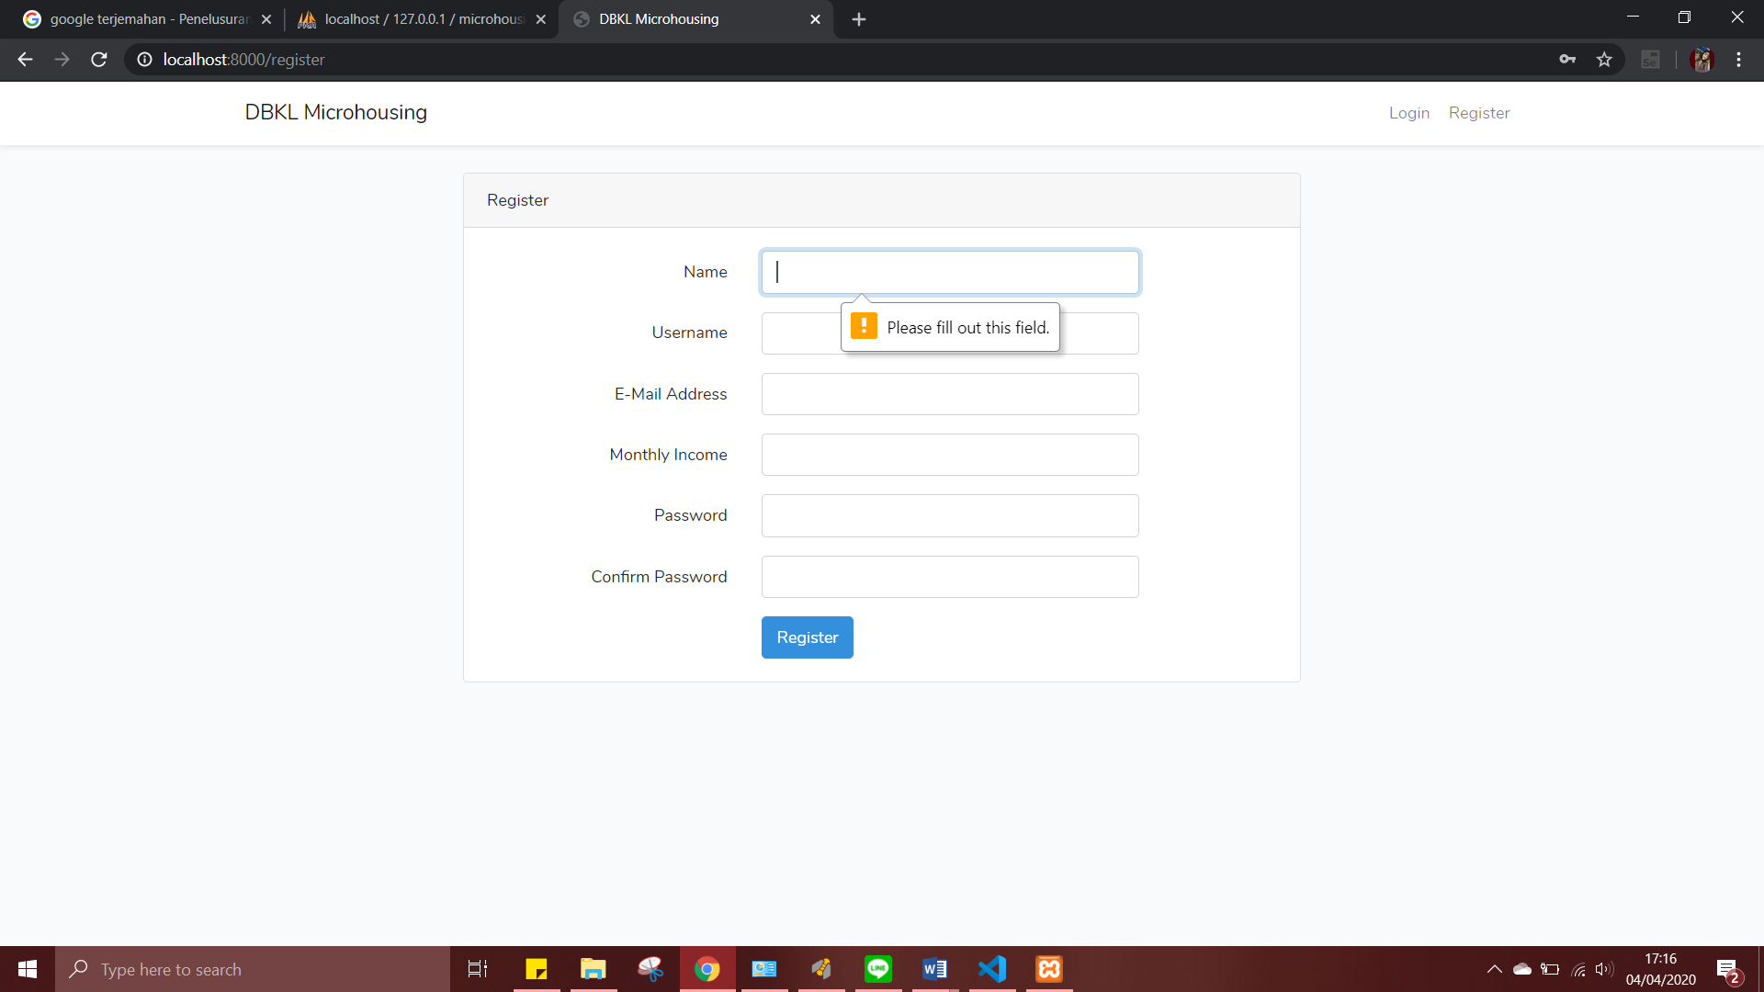

1. Applicant input wrong email or username (username already in the database / not unique) unique() function is for username and email was complete successfully.

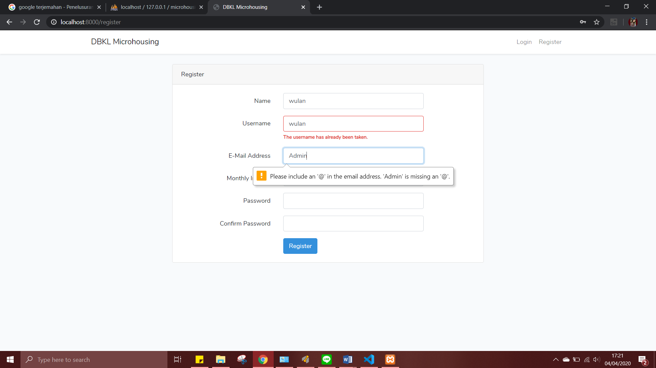

1. Applicant input invalid email and password (too short) class email and password that has class for display error which is @enderror were complete successfully.

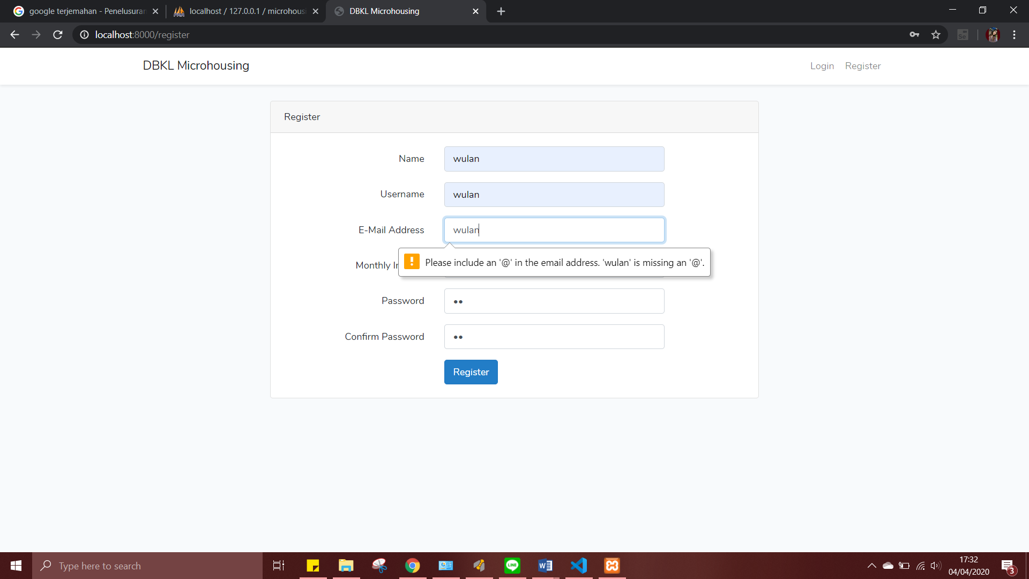

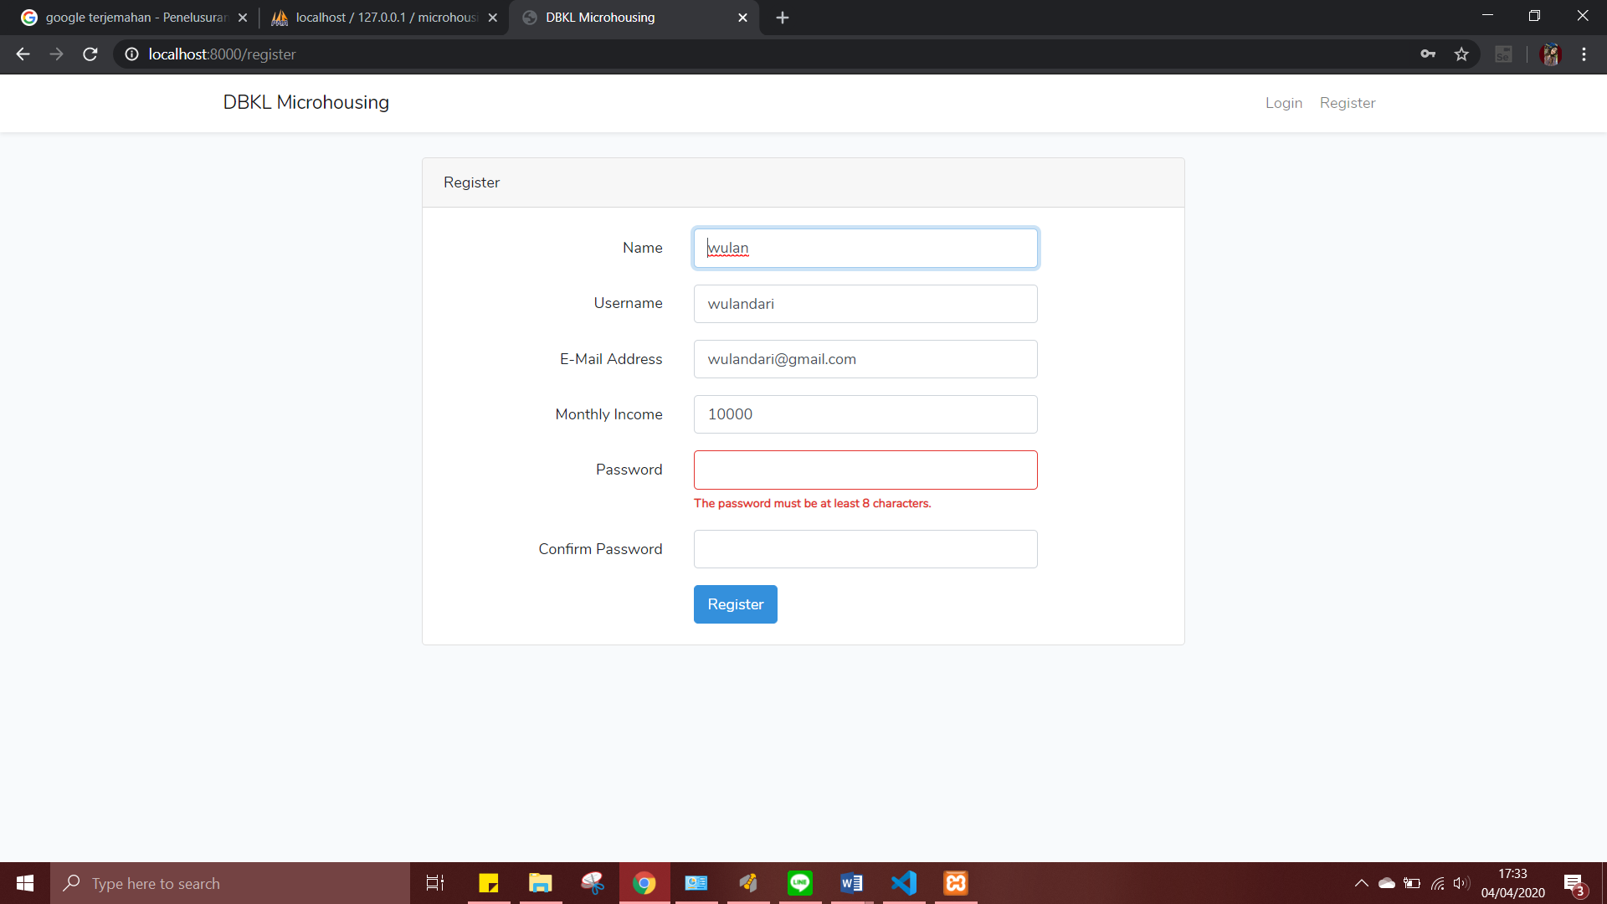

If applicant input valid information, the system will enter the applicant’s information to the database ‘microhousing’ automatically.

1. Password Hashing

When register, the applicant’s password will be saved in the database, and the password will be hashed so that won't be easy to read by others.

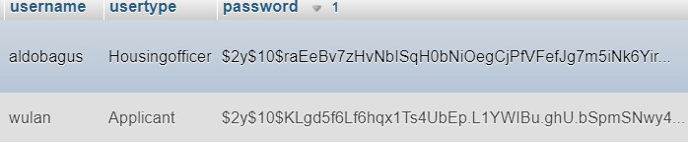

1. **Login**

This loginController function is to validate and separated according to the role as housing officer and as applicant which is will be input manual in usertype (to directed each web page).

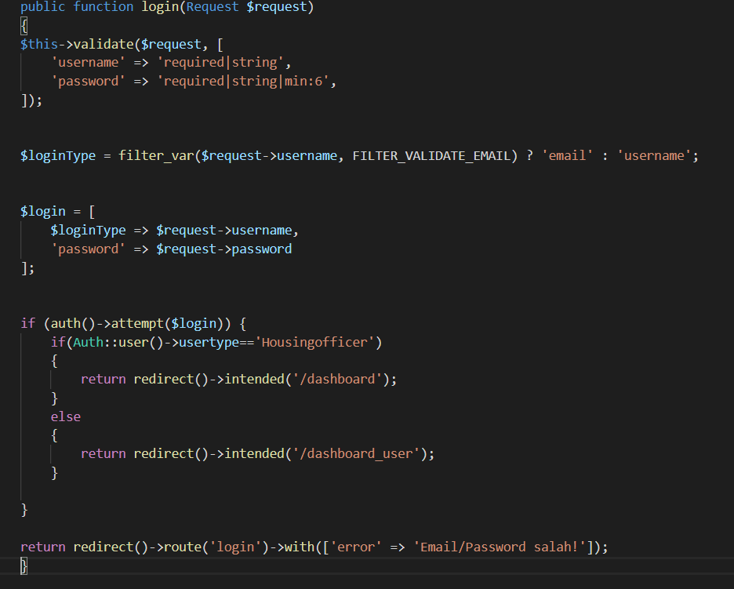

This function to make a form for login and the input will be verified whether it is in the database.

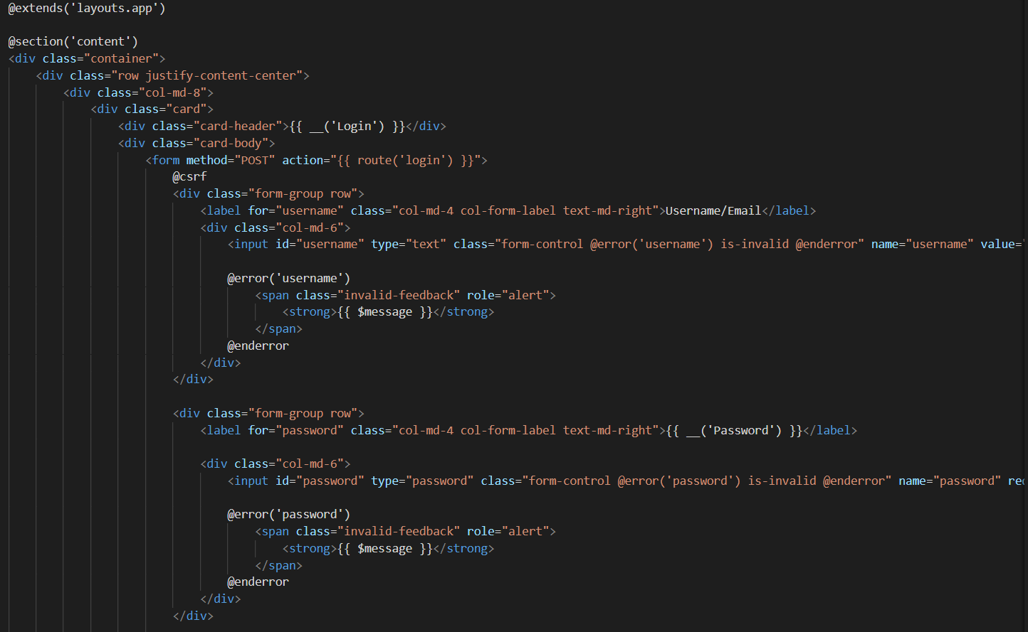

User input invalid username and password, the system will not response and will stay in the login page. User input valid username and password, the system will checking into the database and each user will be direct to their dashboard according to their role.

Applicant Homepage



Housing Officer Homepage

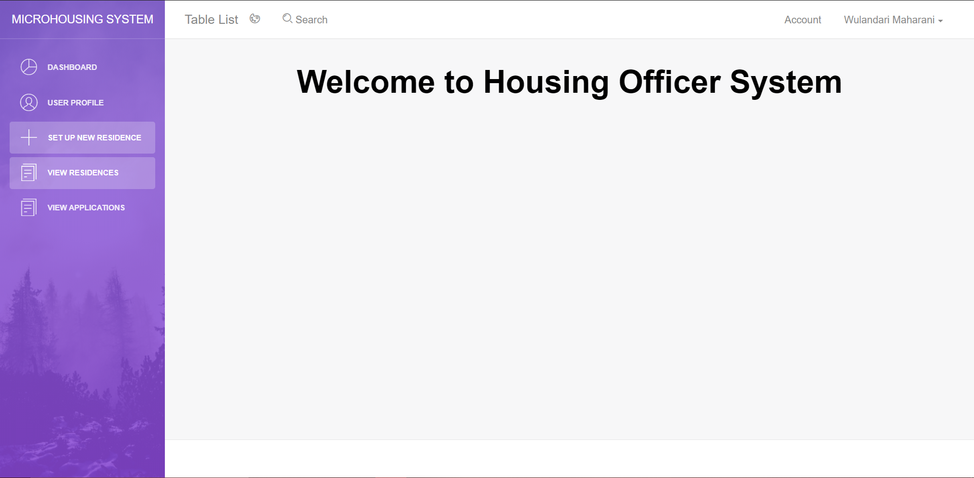

1. **LogOut**

This nav bar will delete the user session which is allocate in master.blade.php. so the website cannot access user information again. If this function is remove, so the user will return to the dashboard login page.

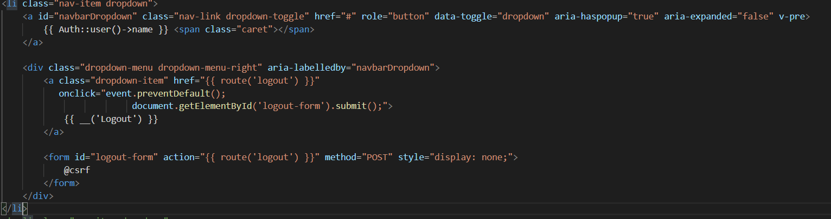

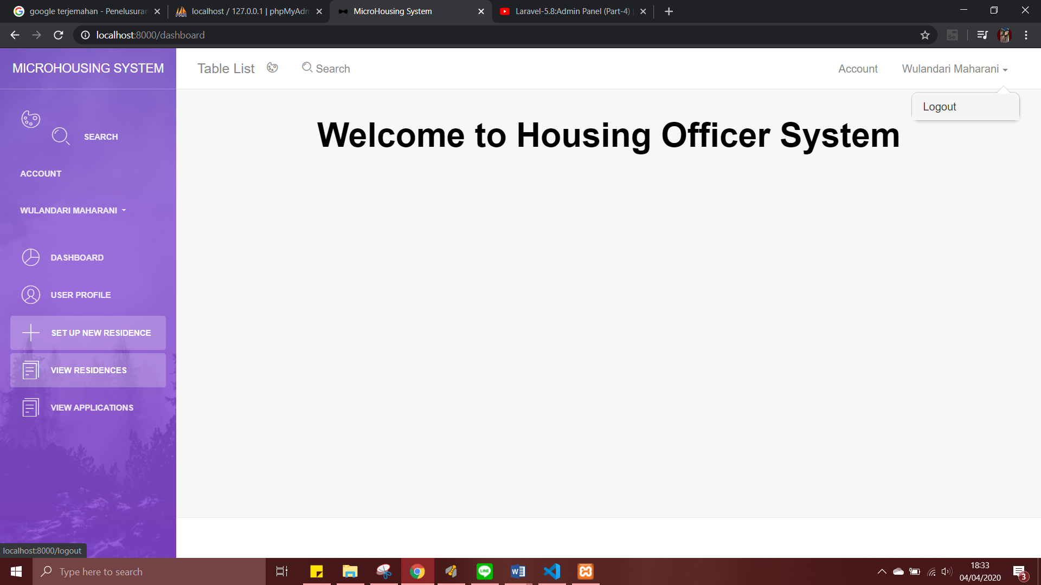

Back to dashboard page



1. **Set Up New Residence**

In this test, the set up new residence will be able to add residence and each variable will input to ‘microhousing’ database in residence table.

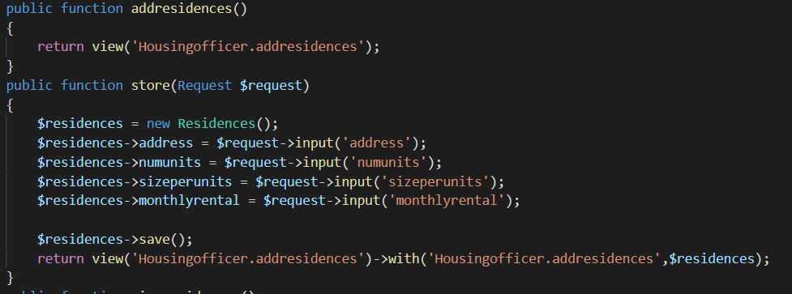

This addresidence.blade.php which is form to input the data

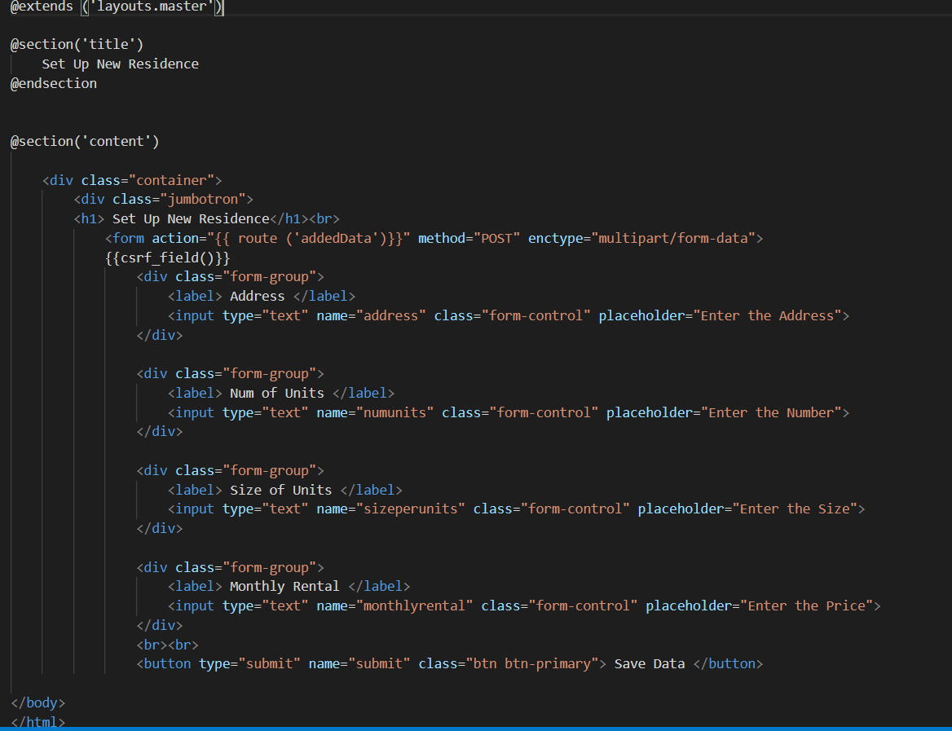

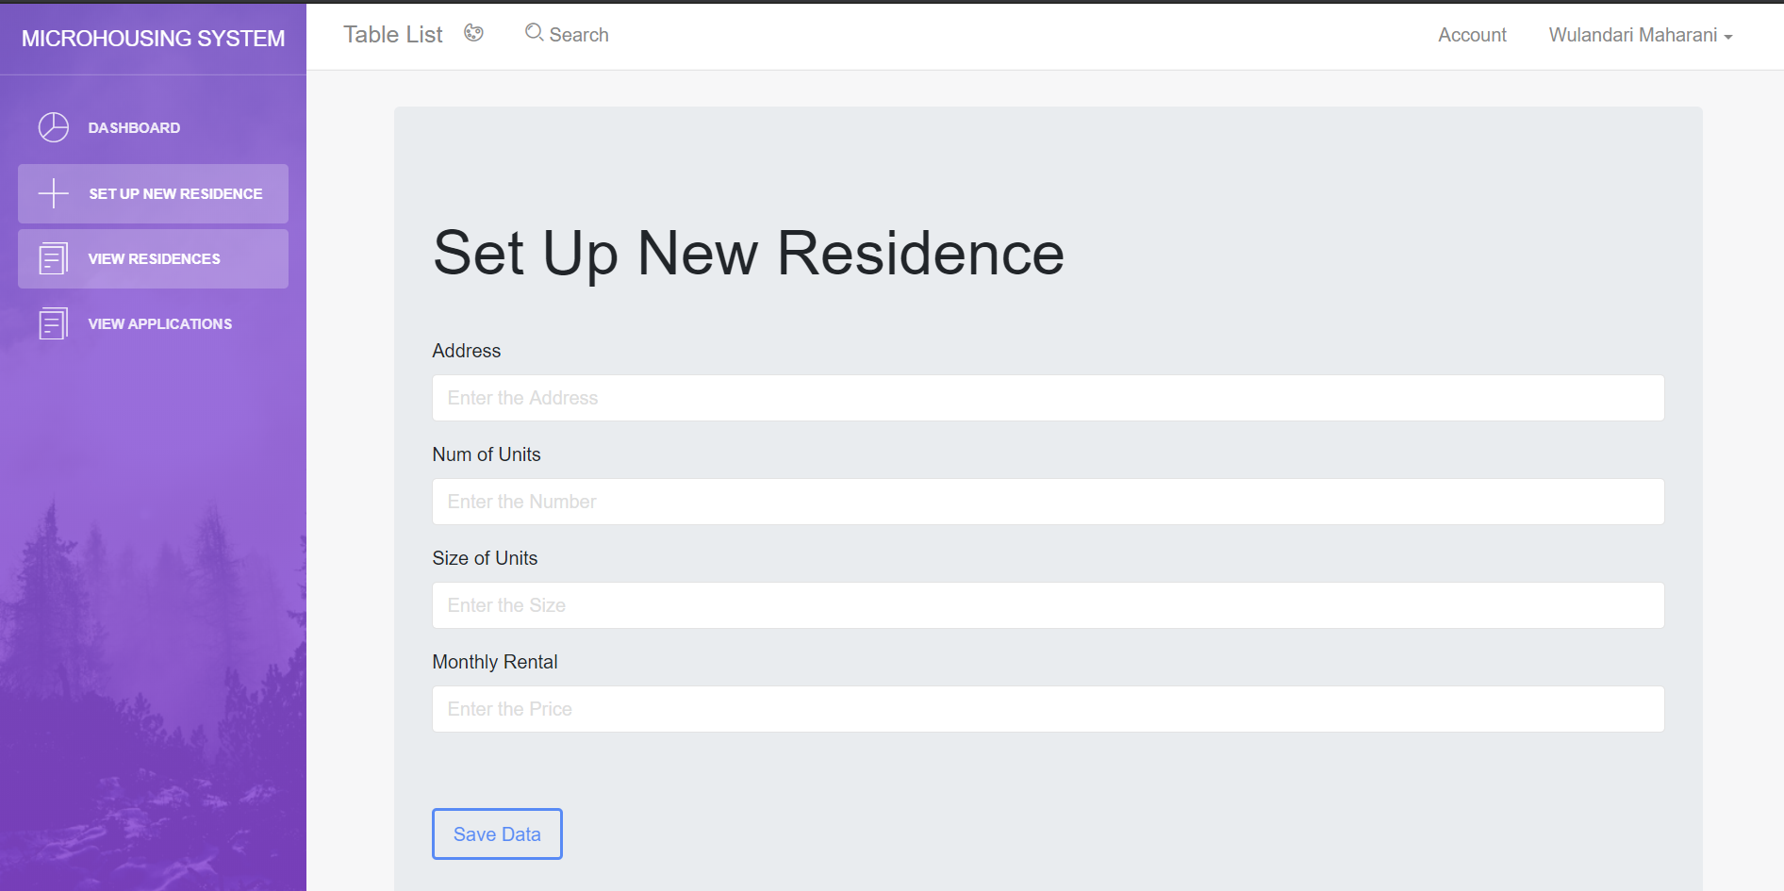

1. **View Residence Detail**

This test, viewresidence.blade.php function runs properly, displaying all the residence in the database. Residence data in the database will be stored in row that is will be send to the housingofficer’s page.

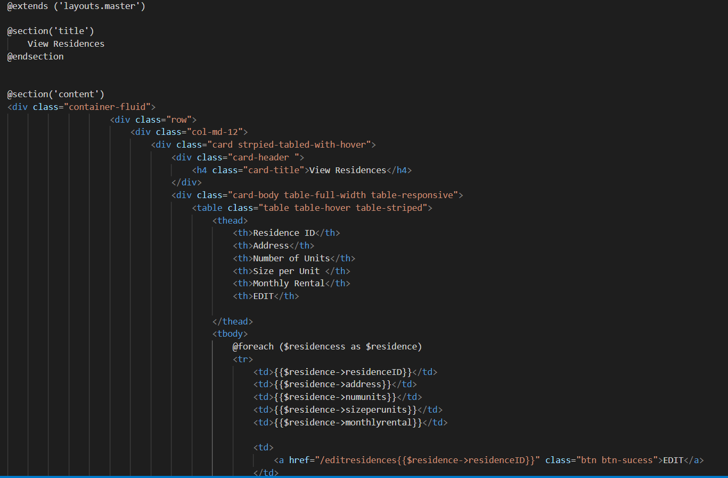

This function to call all the residence which has been inputted and store in the database.

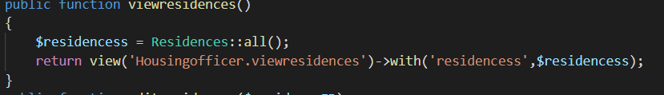

This is the residence data in ‘microhousing’ database.

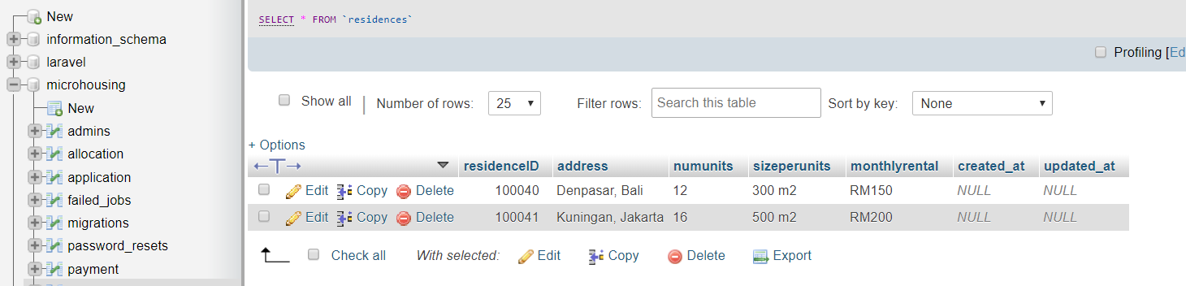

The view residence in the housing officer page

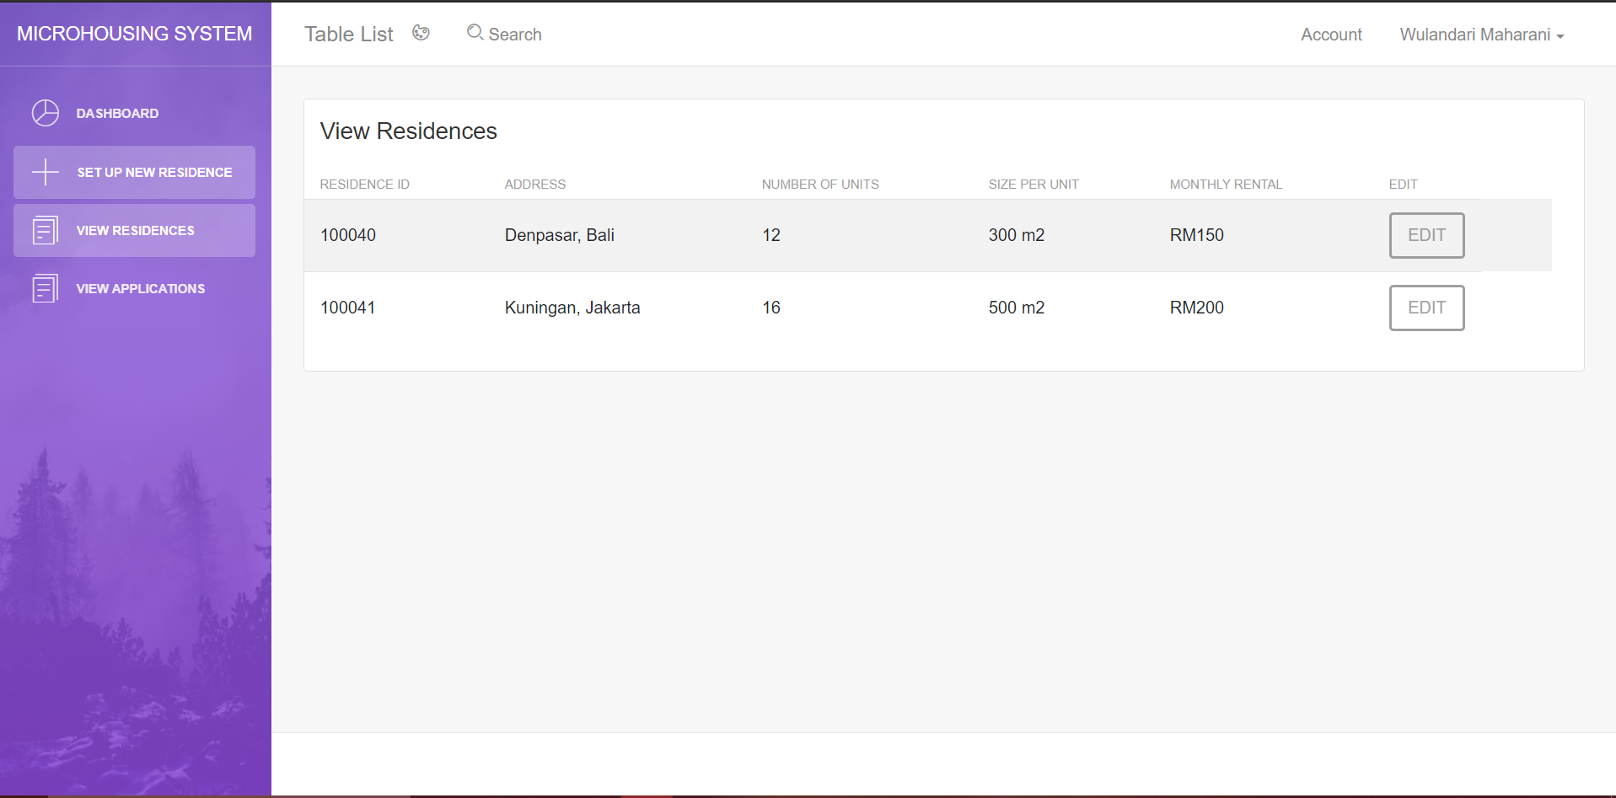

1. **Edit Residence Detail**

In this test will editresidence.blade.php function runs properly. This function useful for editing the residence, which is already input. For editing we need ‘Model’ that will receive data input from the residence model and then update the data into the database.

This is the Residence.model

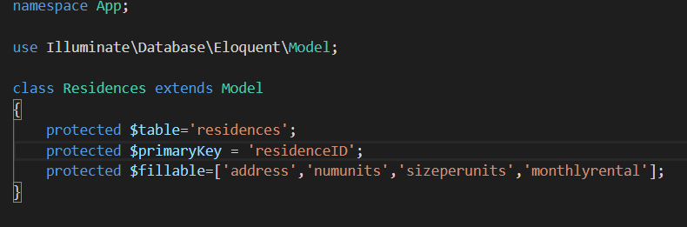

This function is to find the residenceID because when we want to edit every residence has edit button so we will find the residenceID.

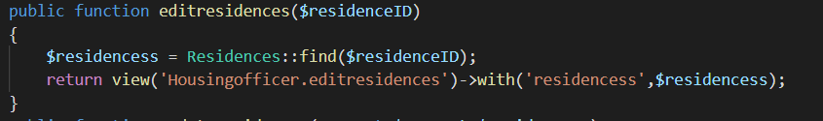

This is the editresidence.blade.php is form for the edit residence.

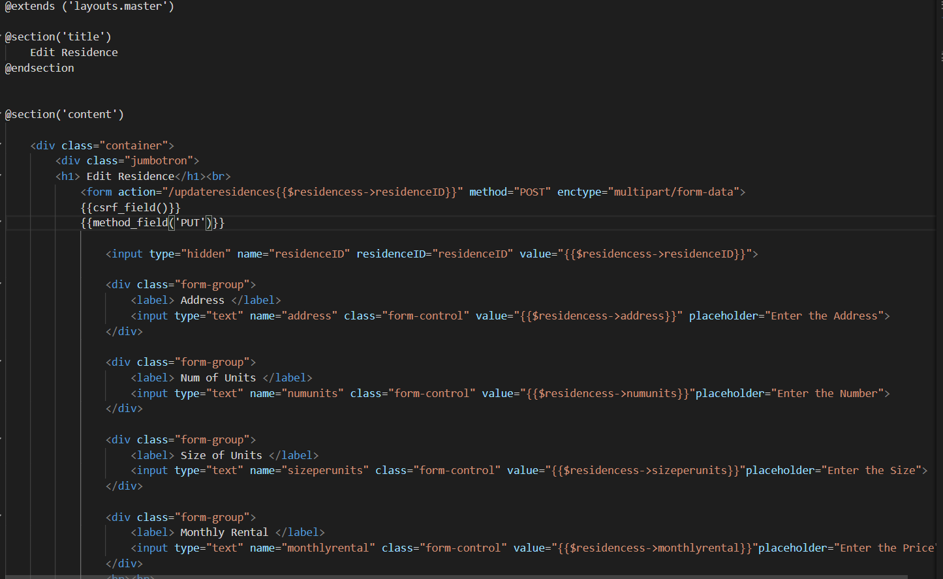

This this display form edit residence

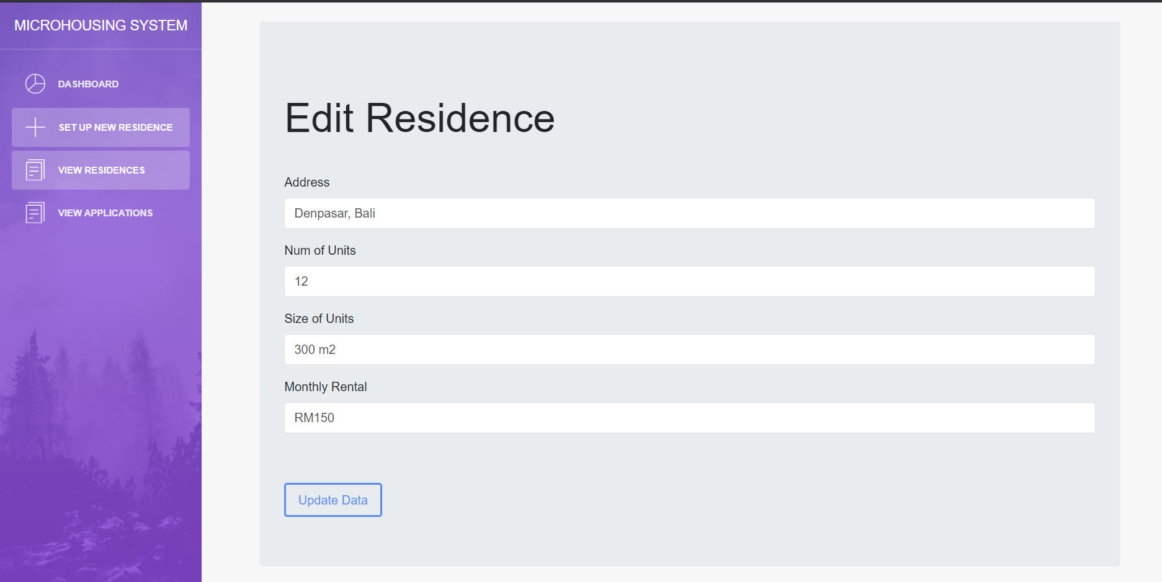

1. **View Applications**

This test, viewapplication.blade.php function runs properly, the applications are displayed in the view application menu for Housing Officer menu, are applications that related to the residence.

This is the form for the view application and the button for delete and allocate but not functioning yet

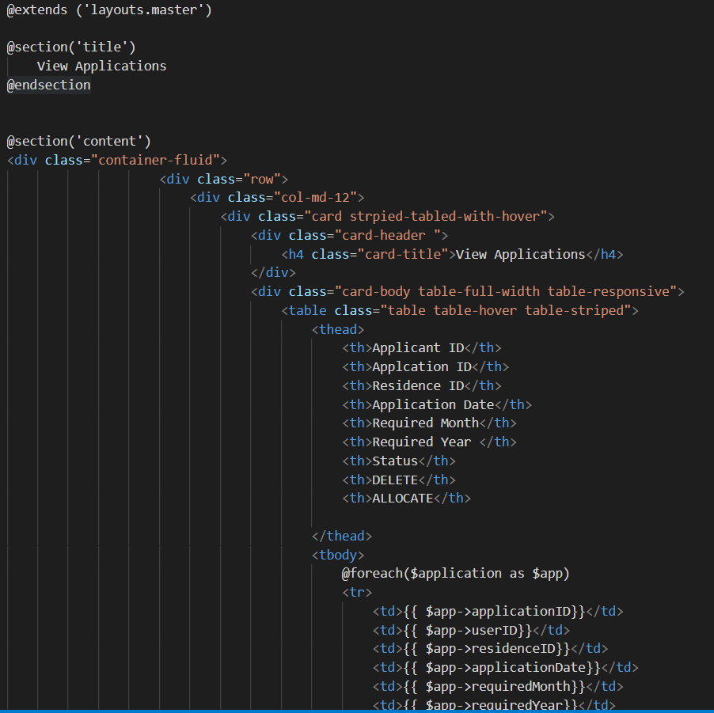

This function is to call the table application in the database, which is input by the applicant

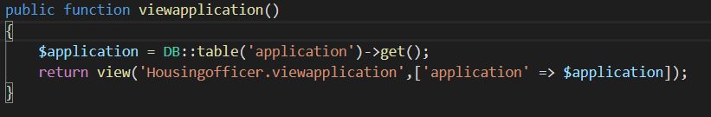

This display for view applications from input by applicant

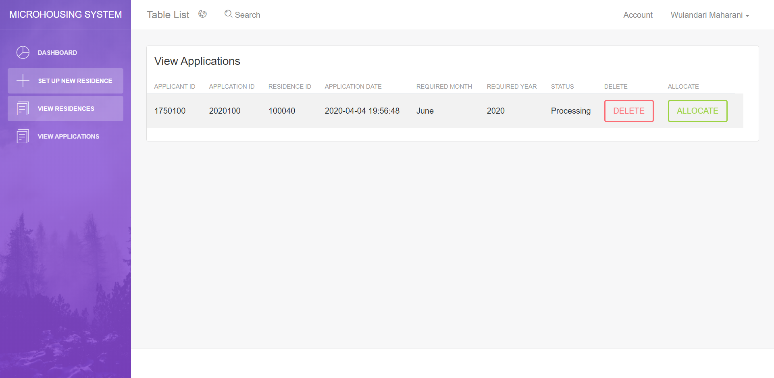

1. **Submit Application**

This test applicationcontroller , will be able to submit application and each variable will input to ‘microhousing’ database in application table.

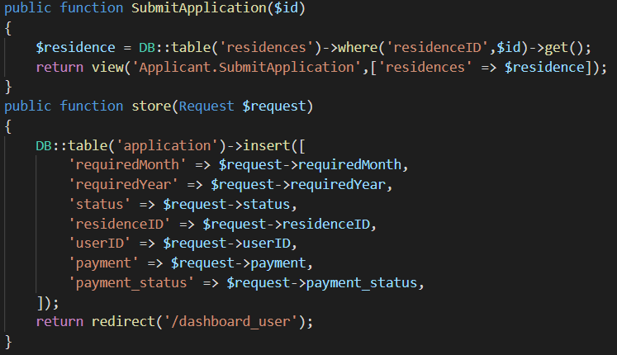

This is form for the submit application that is submitapplication.blade.php

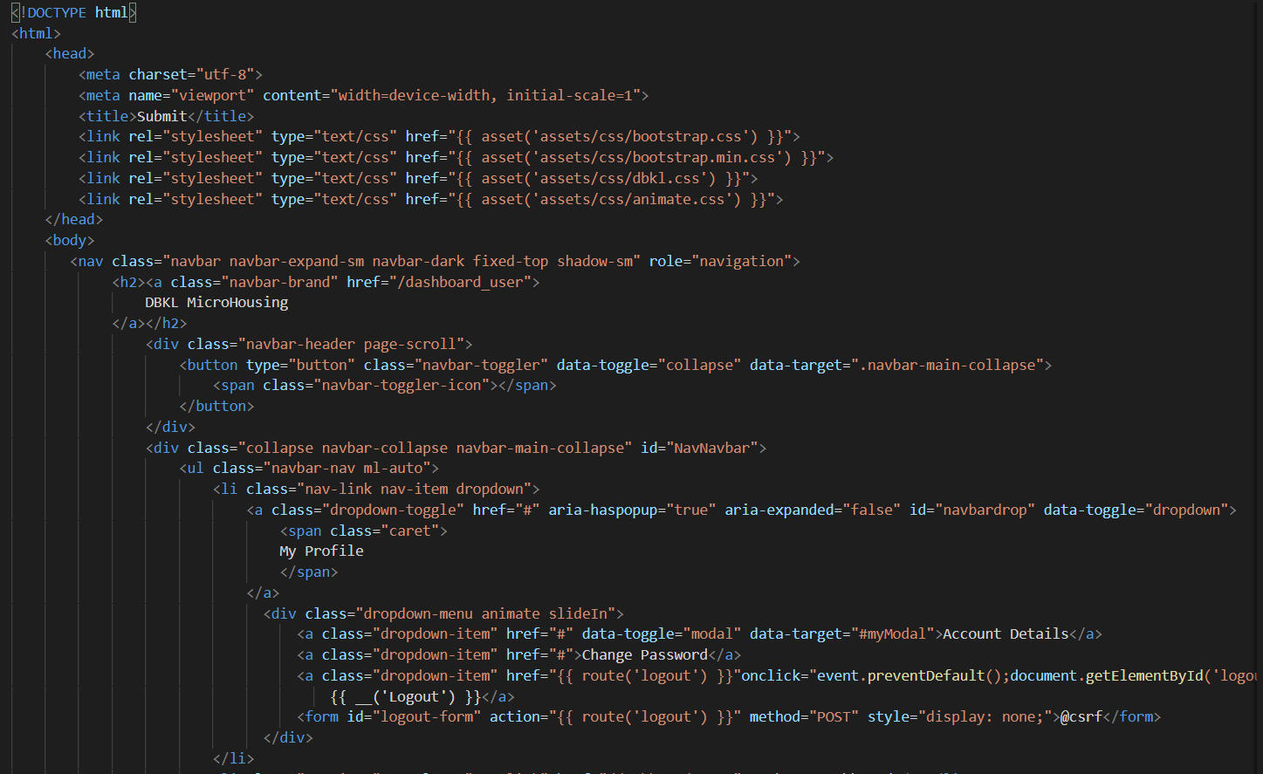

This is display submit application page

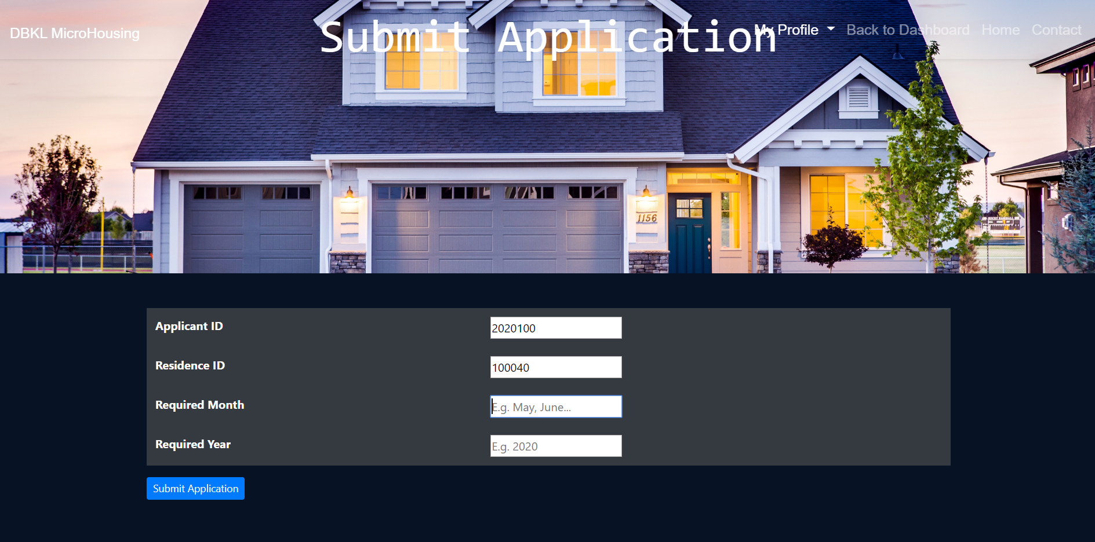

If the applicant input invalid information that is required month and required year (Not fill), the system will display an error.

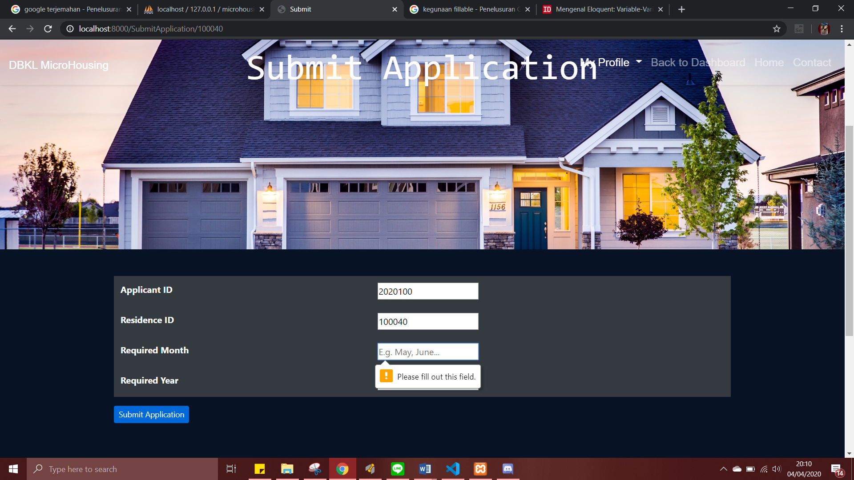

1. **View Residence (Applicant)**

In this test, viewresidence.blade.php which is the folder function runs properly, displaying all the residence which is input by the housing officer and all the residence data in the database.

This is form for the view residence in the applicant role

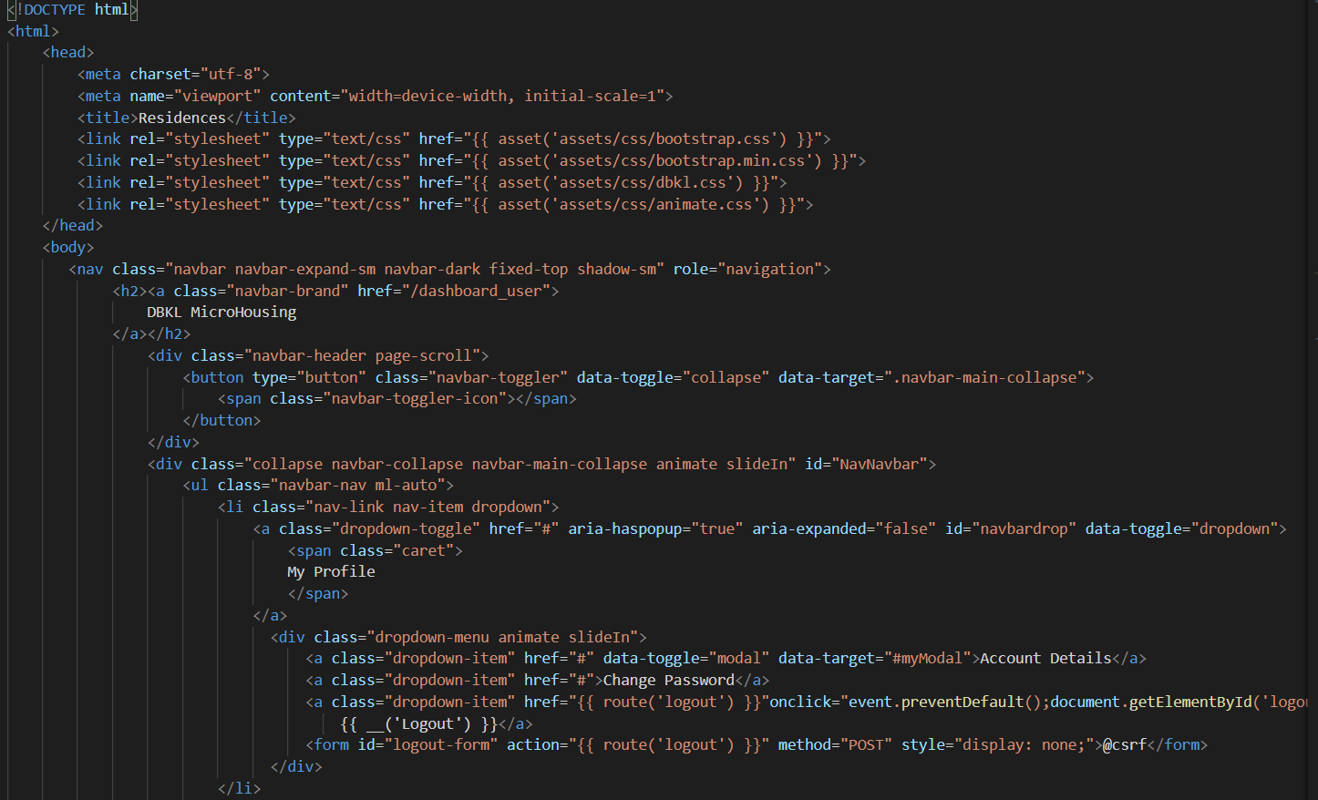

This function is to call the table application record in the database

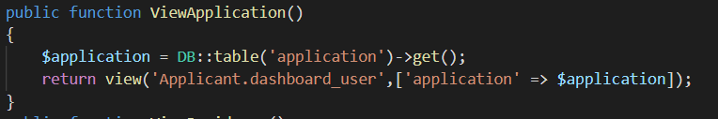

This is display view residences

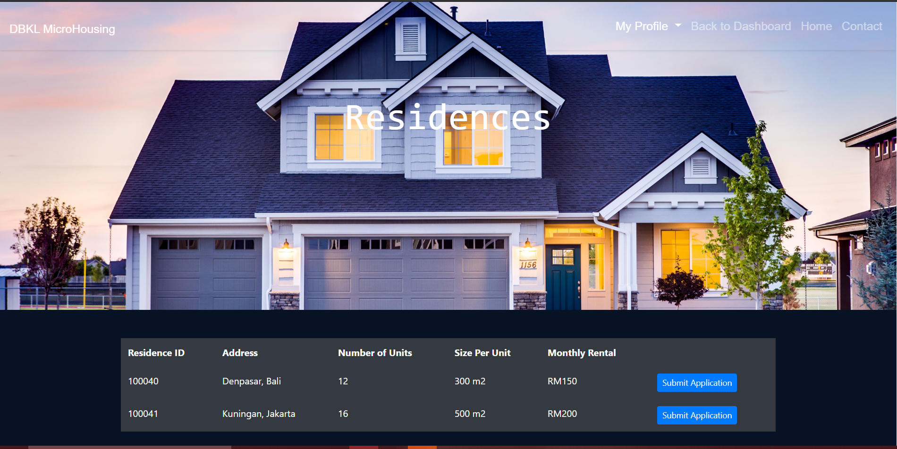

1. **View Application**

This test ensure the applications that are display the viewapplication which is the function in the applicant folder. The applicantcontroller functioning properly. In this code the applicantID will be login first, the the applicant id will look for, and the application will display the application that has the same applicantID thas has login

This is the form table will be display in the applicant dashboard

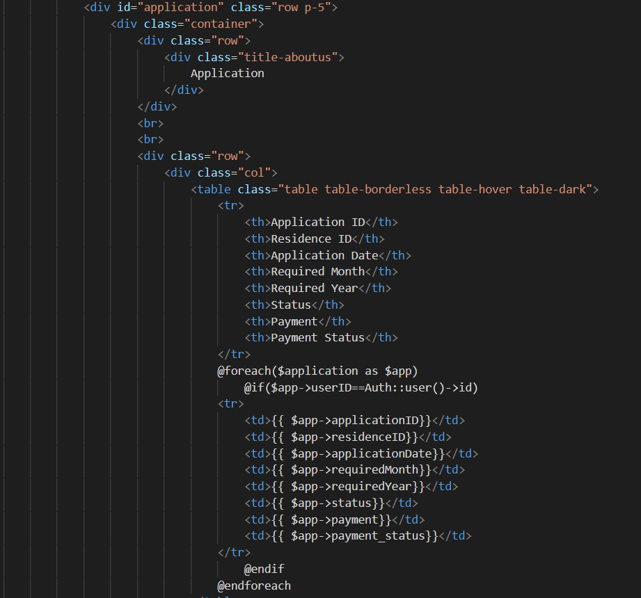

This function is to call the applications which is in the database and already input by the applicant.

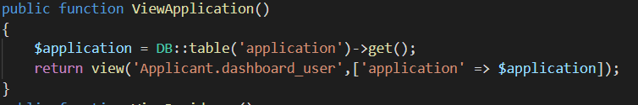

This display the application which is already input

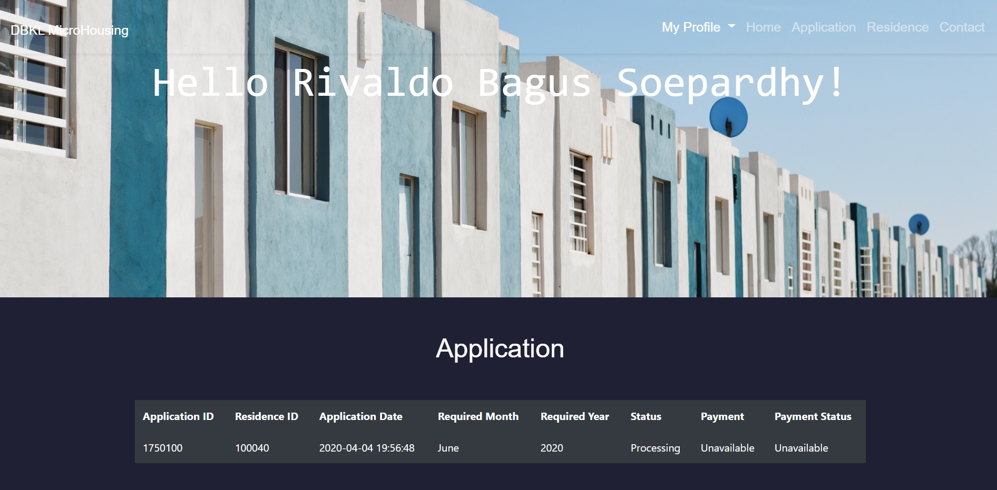

For all the function above, we are using route it is to handle our request in the Url and then direct the application to call a specific page / resource which is route to housing officer page and applicant page

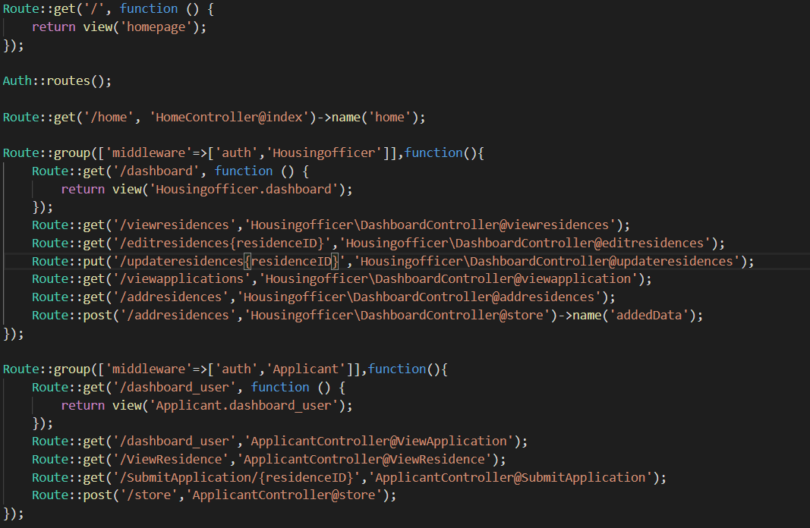

Integration Testing

We use Selenium-Web Driver application. The system will run based on the functions existed in each use case. The result of the testing will be exported in a Python .py file.

1. Login Applicant

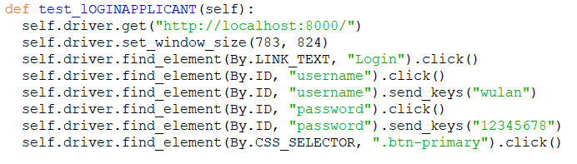

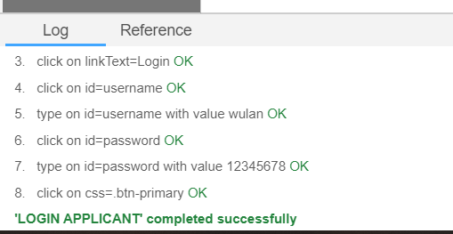

1. Register Applicant

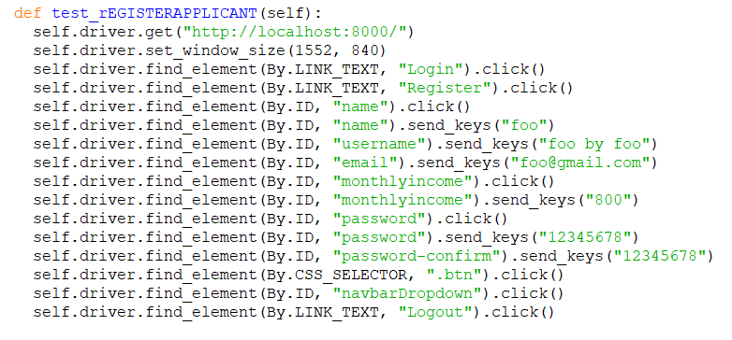

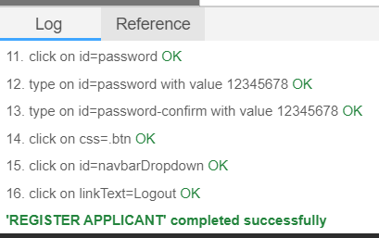

1. Submit Application – Applicant

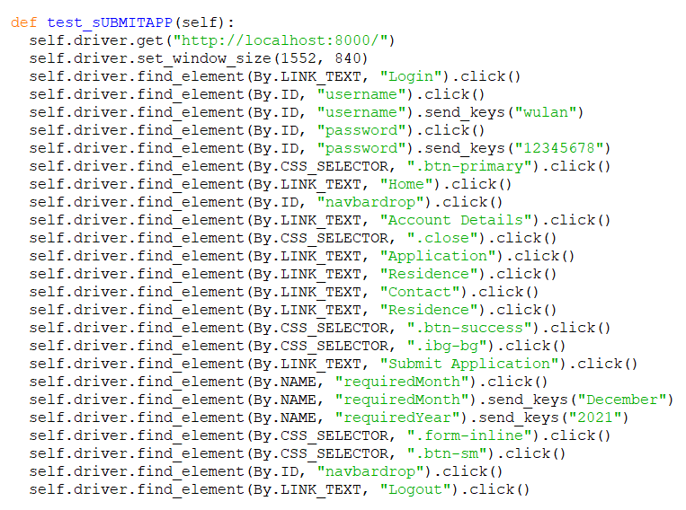

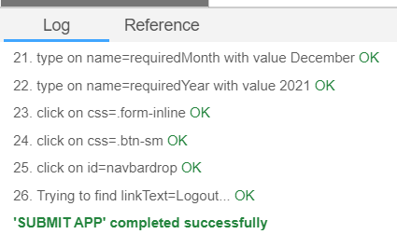

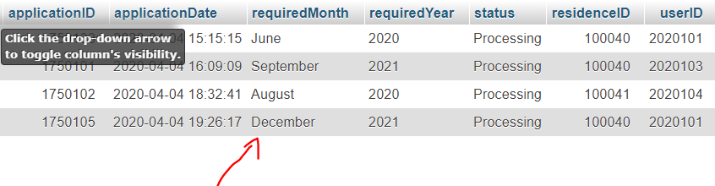

1. Login & Logout Housing Officer

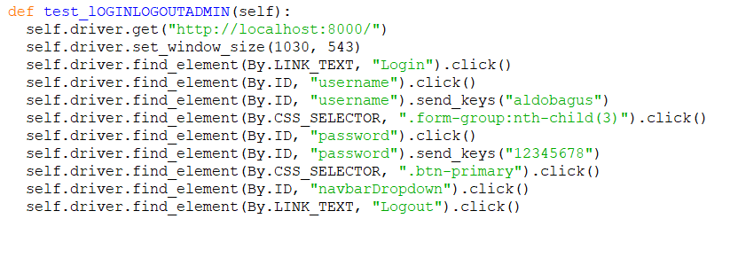

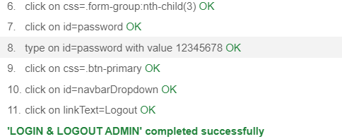

1. Set Up New Residence – HousingOfficer

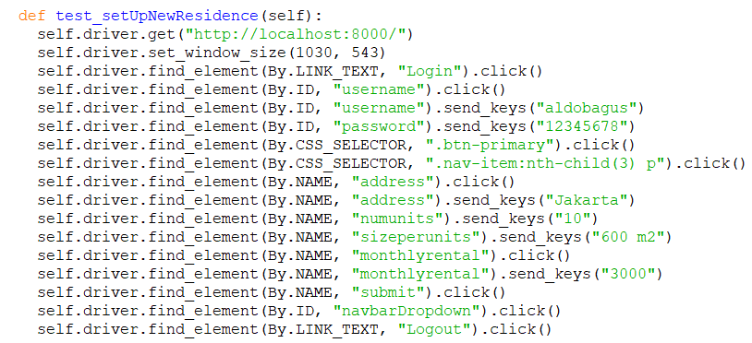

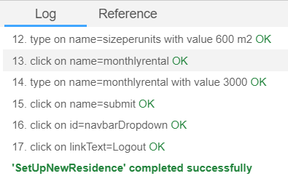

1. Edit Residence – HousingOfficer

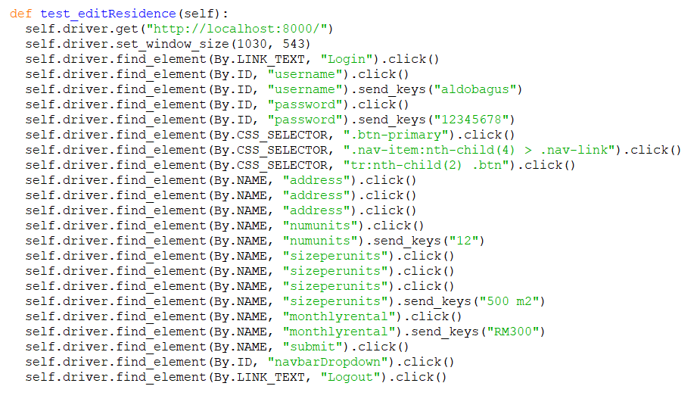

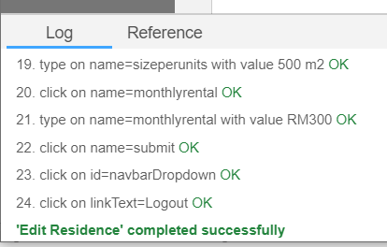

System Testing

Functional Requirements

We will test the system according to the functional requirements.

1. **Register for Applicant**

Testing start from the dashboard which is you enter the URL this is the dashboard page and register page.

The dashboard page



The register page

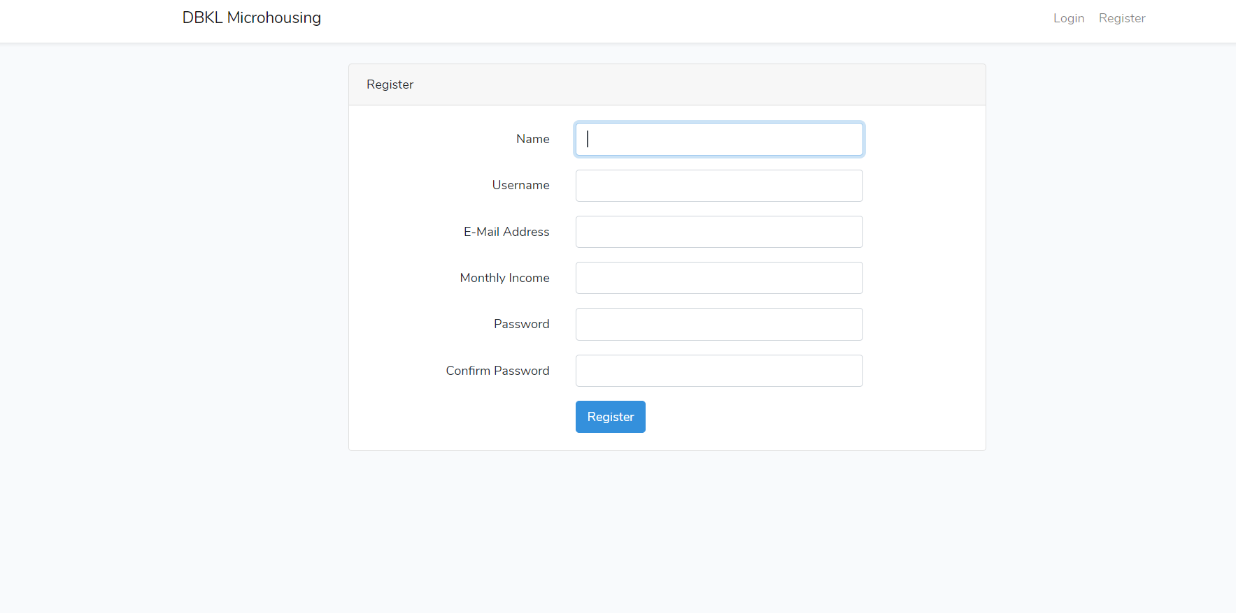

1. Applicant input blank information



1. Applicant input wrong email or username which is already used



1. Applicant input invalid email and password (too short)





1. **Login**

Login page same location in the dashboard

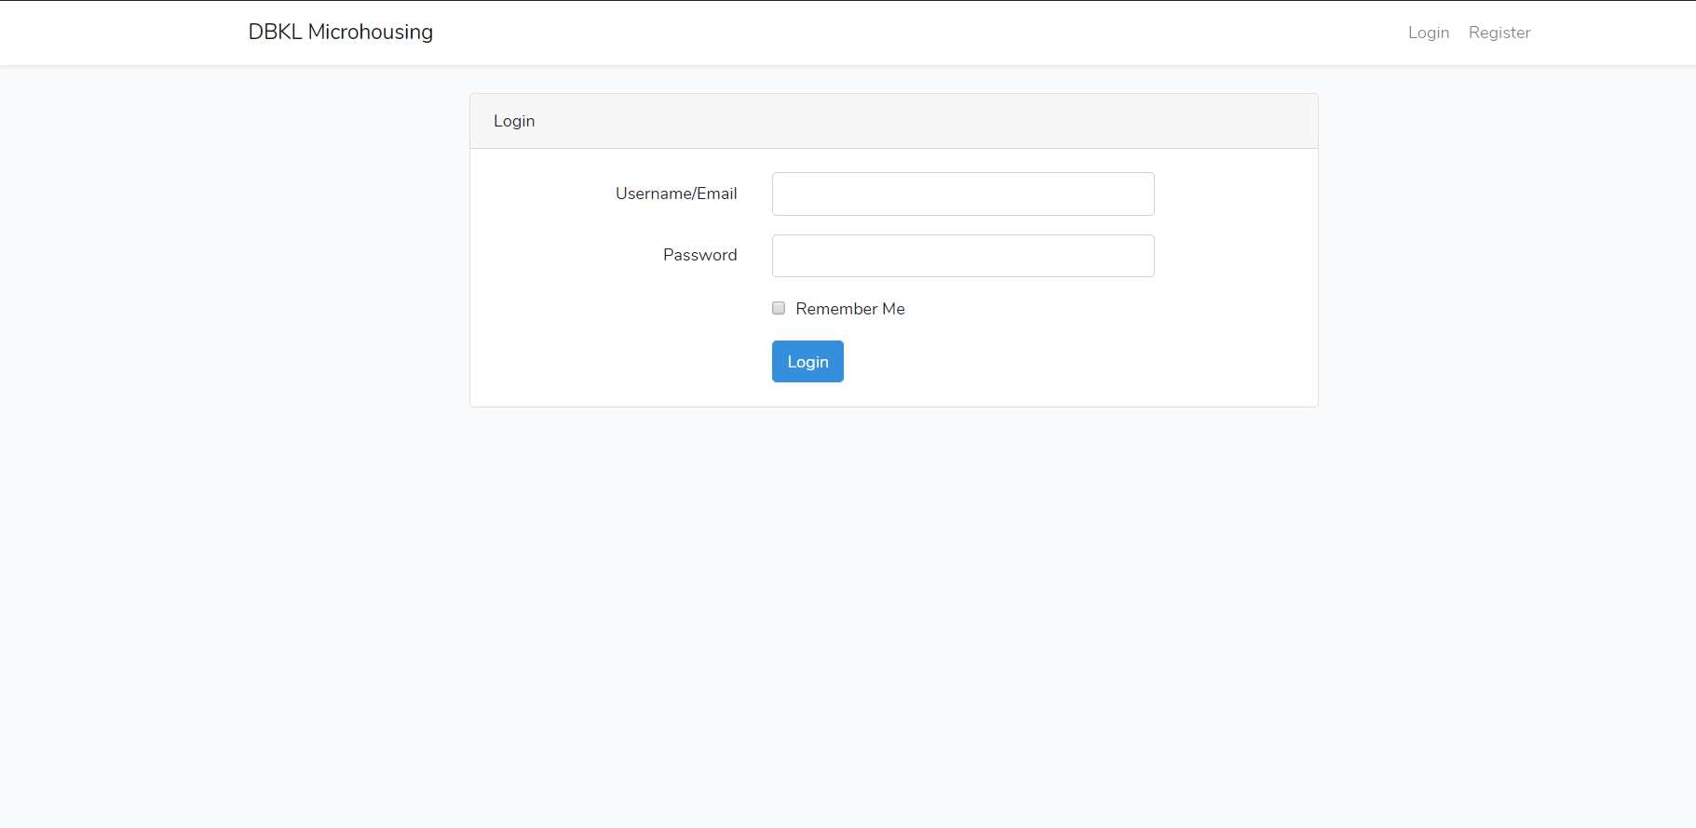

Applicant Homepage



Housing Officer Homepage



1. LogOut

After login there are logout button above the page



Back to the dashboard



1. **Set Up New Residence**

Set Up New Residence menu located in housingofficer page



1. **View Residence Detail**

To view residence, which does the housing officer in the housing officer page already input



1. **Edit Residence Detail**

To edit the residence and update the data in housing officer page



1. **View Applications**

To view the application which does the applicant already input.



1. **Submit Application**

To submit the application

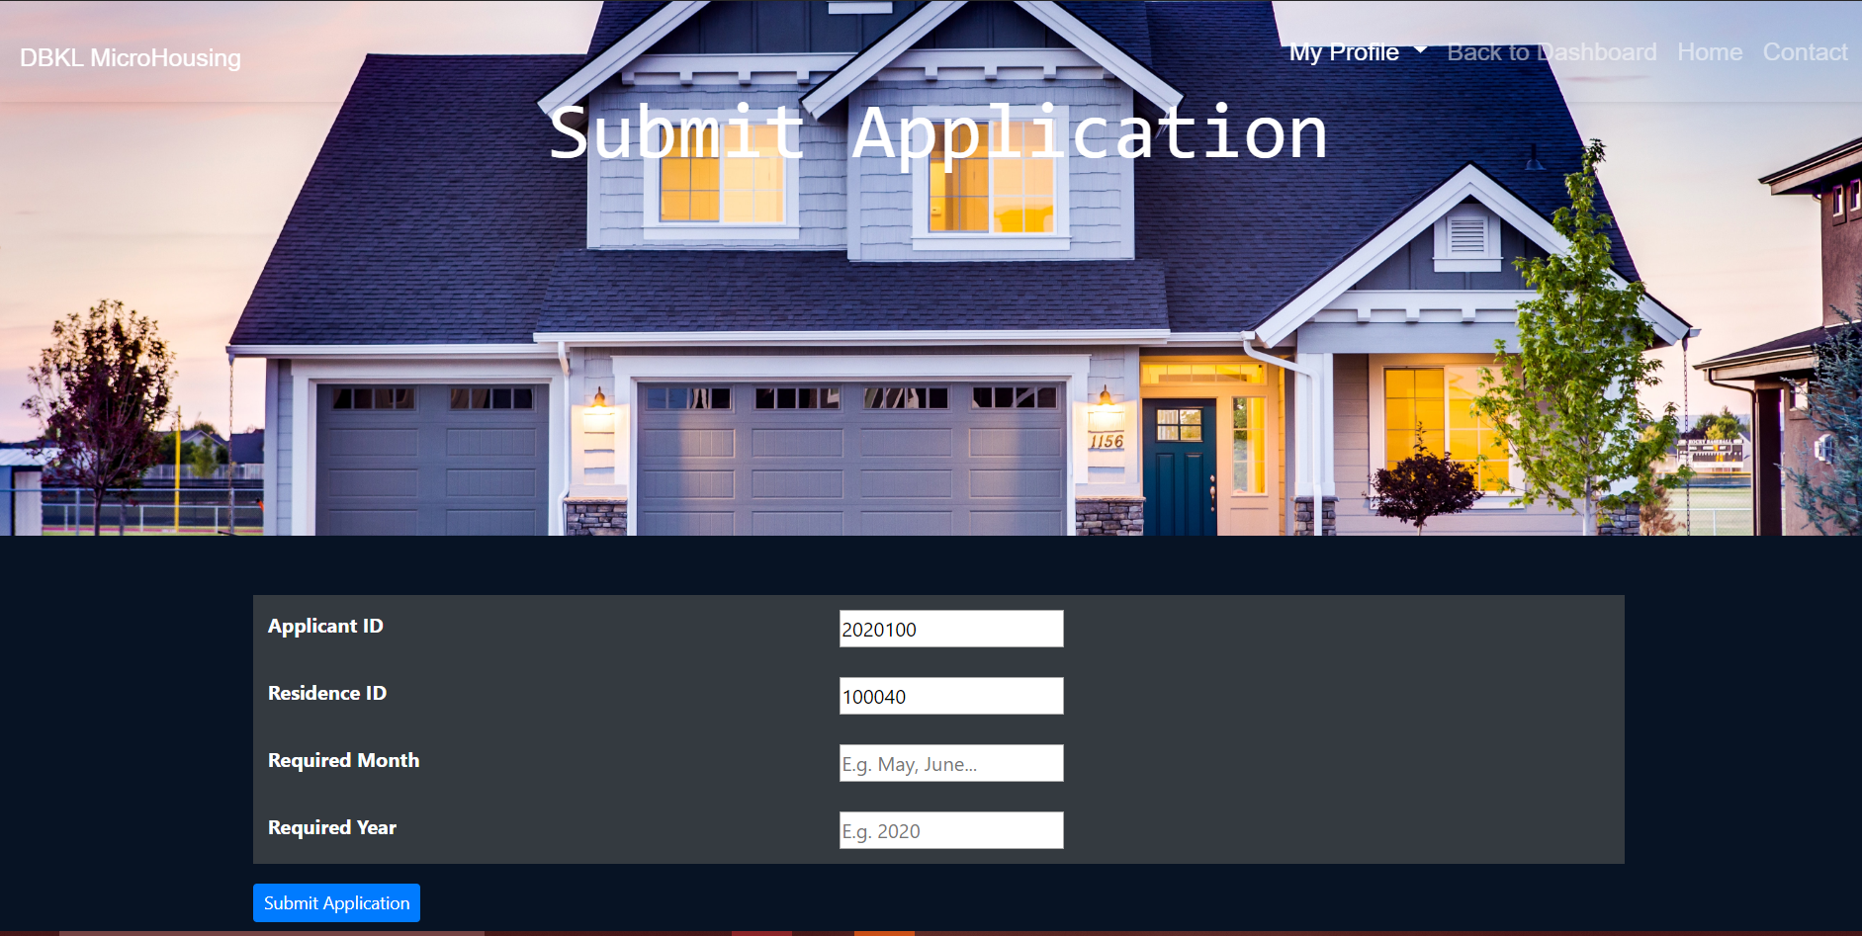

1. Applicant did not input the required month or required year

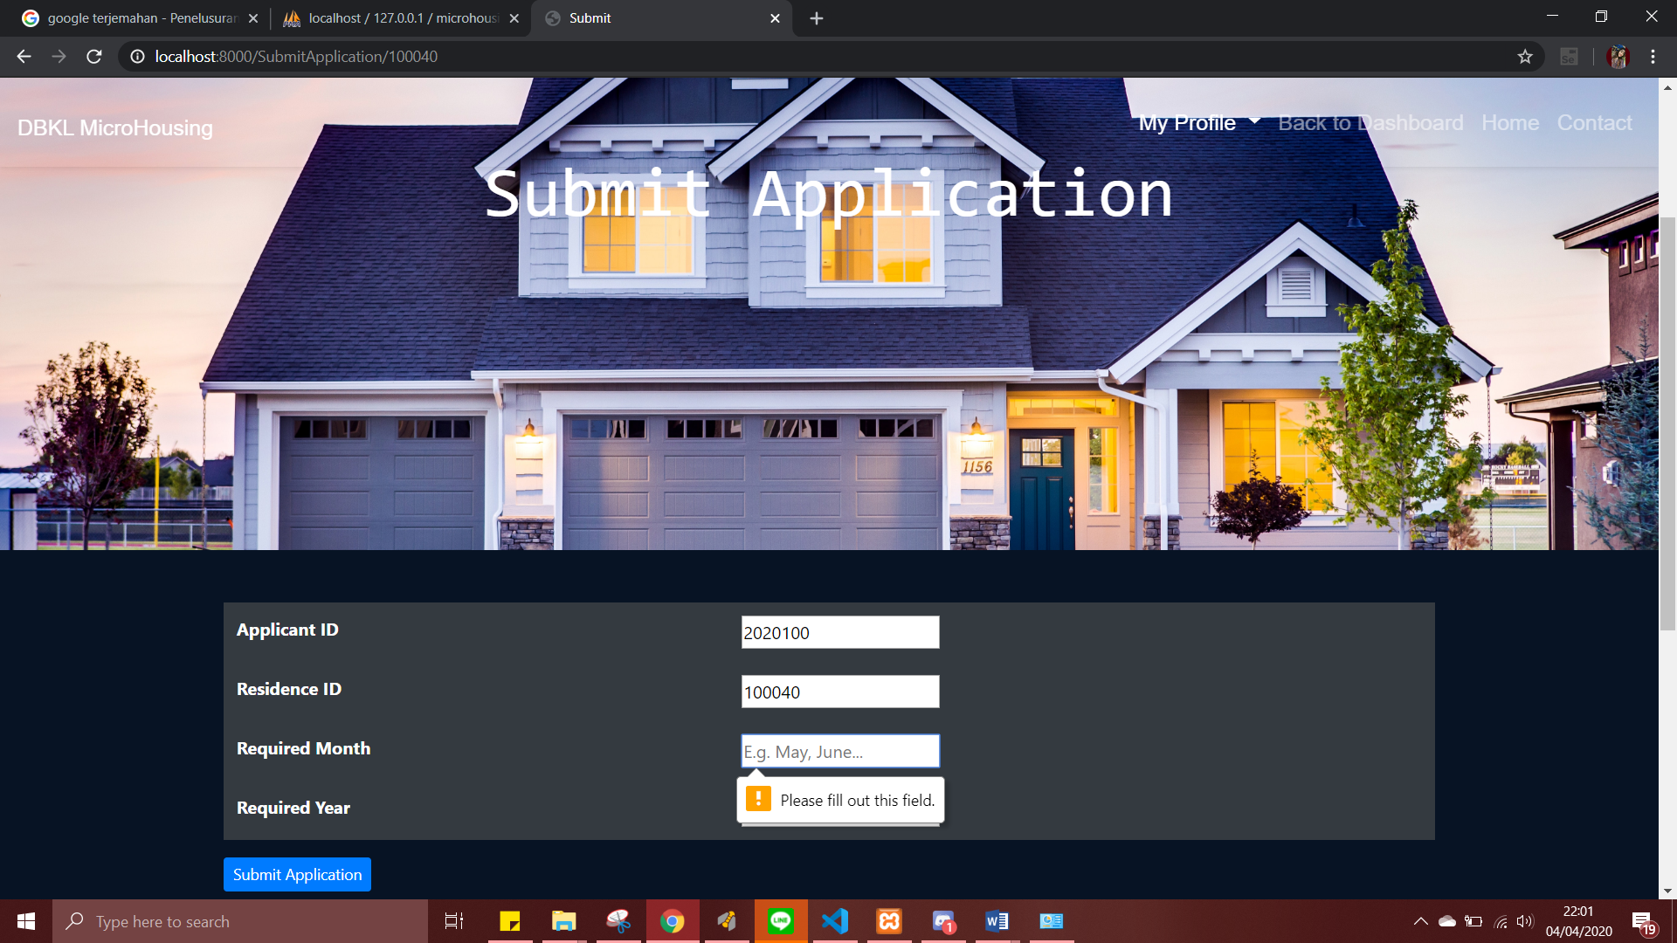

1. **View Residence (Applicant)**

To view all residence which is already make by the housing officer



1. View Applications

To view submitted application by the applicant



Non-functional Requirements

We will test the system according to the non-functional requirements that have been determined previously.

1. Security requirement: using login system for authorization to prevent unauthorized access of certain parties.



1. Usability: the system should be easy to access for Housing Officer and Applicant.





1. Accuracy and precision: Integrity which data has been inputted will still be the data entered. Data will be stored with it’s real value.







1. Modifiability: data can only be change by authorized user (HousingOfficer).









Test Analysis Report

After conducting all of the required tests, we can say the system is working normally.From unit, integration and system testing, we can say that the system and codes are working fine and has passed the testing process. The scope of our testing is to make sure every functions of the system can work perfectly according what the tasks they are assigned. Overall, we have found bugs and errors and have corrected it.

Updated Gantt Chart, Trello Board, GitHub

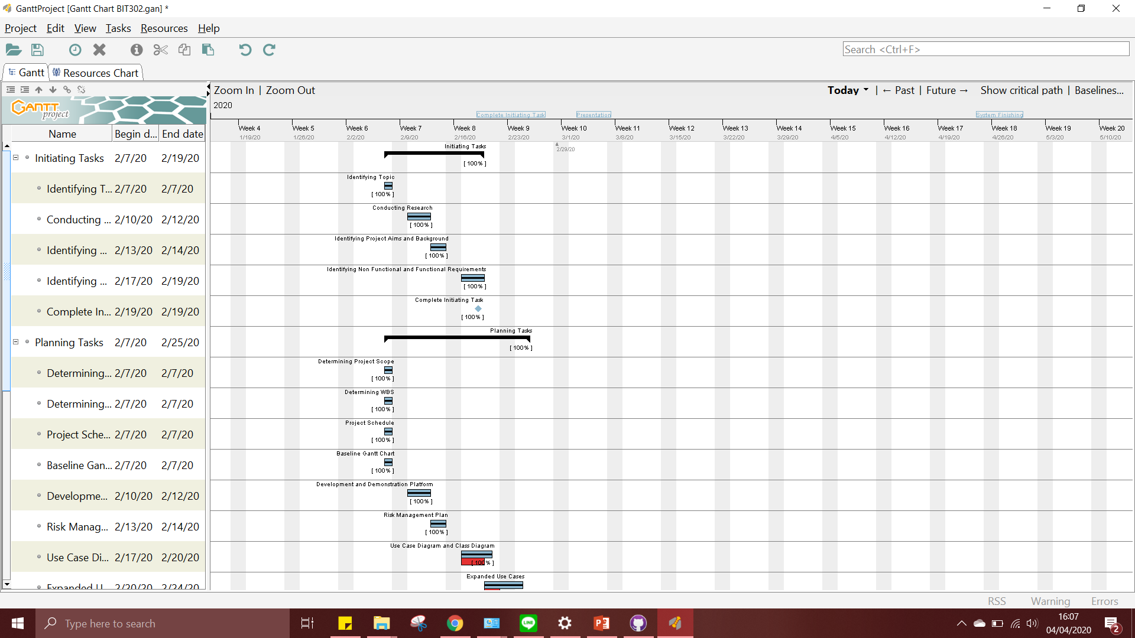

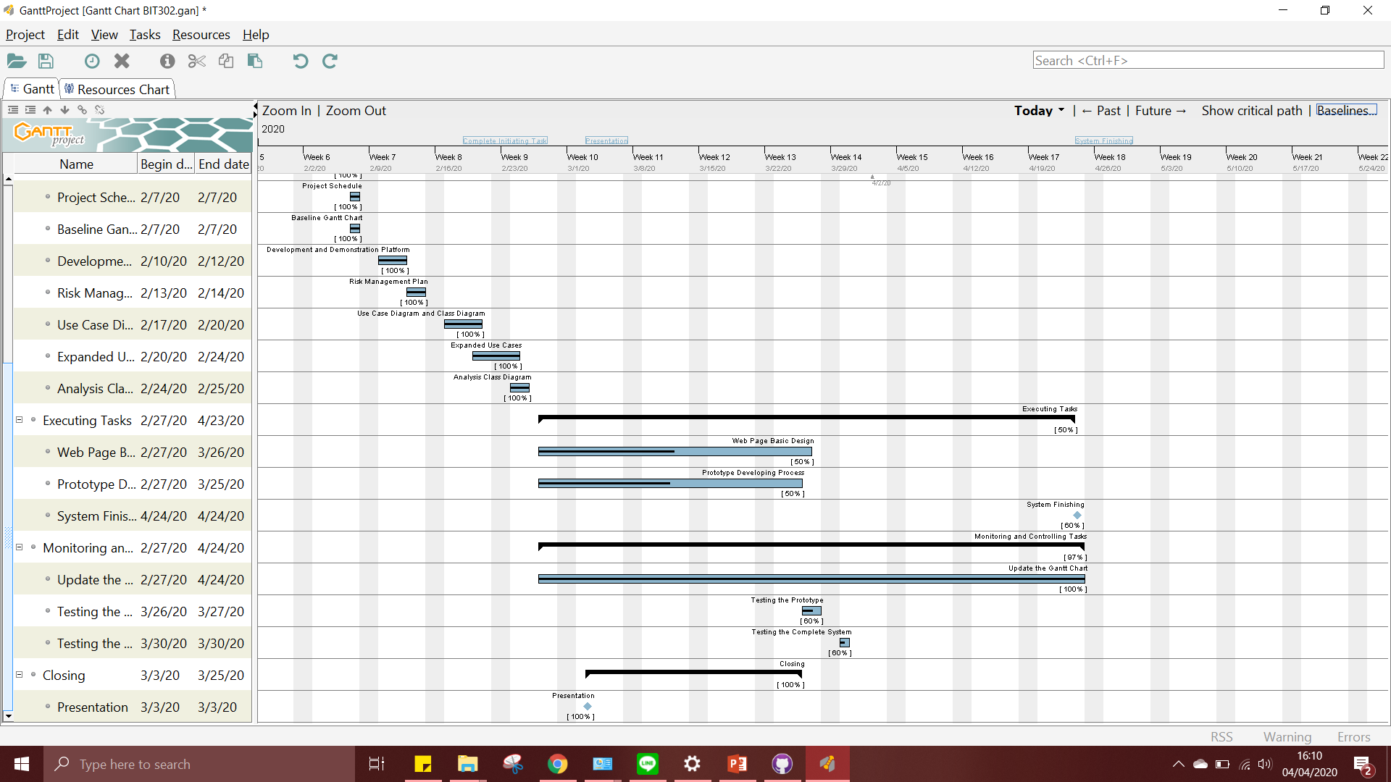

Baseline Gantt Chart

